HISTOLOGY (Study of tissues)

A tissue is a group of similar cells organized into a structural and functional unit. It is a group of cells of similar structure organized for carrying out a particular function(s).

Characteristics of tissues

* Cells of a tissue are physically linked.
* The cells of a tissue may be interspersed with intercellular substances.
* A tissue may comprise one or more types of cells.
* A tissue is specialized to perform a particular function(s).

ANIMAL TISSUES

Early in development, the cells of the growing embryo differentiate into three fundamental embryonic tissues called germ layers.

* Ectoderm which forms the outer layer of the skin and the nervous system.
* Mesoderm which forms muscles, connective tissues, skeleton, kidneys and circulatory and reproductive organs.
* Endoderm which forms the lining of the respiratory tract and urinary bladder. It also forms the glands associated with the guts and respiratory tract.

Therefore the germ layers in turn differentiate into different cell types and tissues that are characteristic of the vertebrate’s body. Tissues are joined to each other by proteins. The point of connection between two cells is a junction.

In adult vertebrates, there are four principle kinds of tissues which include; epithelial tissue, connective tissue, muscular tissue and nervous tissue

EPITHELIAL TISSUE

This is a collection of closely packed single and multilayered compound sheets of cells covering the external and internal surface of the body of an organism.

Characteristics of epithelial tissue

1. Cellularity- Epithelial tissue consists of tightly packed cells that are firmly attached to each other with little intercellular material between them. Epithelial cells are held firmly together by small amounts of carbohydrate cementing substances and by special intercellular junctions between the cells.
2. Polarity-The bottom of epithelial cells rests on a basement membrane composed of a network of fibres which include collagen. The portion of epithelial cells attached to the basement membrane is called the basal surface, the opposite end facing the external environment or the lumen of the body cavity is called the apical surface/free surface.
3. Avascularity- There are no blood vessels in the epithelial tissues hence the tissue lacks vascularity. However, nerve endings may occur in the epithelium.
4. Supported by connective tissue- Epithelial tissue receives nutrients by diffusion from underlying connective tissue through the basement membrane. As the epithelial cells are not supplied with blood vessels, they rely on diffusion of nutrients and oxygen from lymph vessels which run through nearby intercellular spaces.
5. Regeneration- Epithelial cells have a high regeneration capacity due to rapid cell division. This gives the epithelial tissue quick recovery after any injury or abrasions.
6. Germ cell origin- Epithelial cells are derived from all the three primary layers; ectoderm, mesoderm and endoderm.

CLASSIFICATION OF EPITHELIAL TISSUE

Epithelial tissues are classified according to the number of cells/layers and the shape of the individual cells.

Epithelial tissue

Simple epithelium (one cell layer thick) compound (more than one cell layer thick)

Pseudostratified squamous cuboidal columnar ciliated stratified transitional

1. Simple squamous/pavement epithelium

It consists of a single layer of thin and flattened cells. They are so thin that the nucleus causes a bulge and it is centrally placed, with a disc shape. Cells are irregular with tapering edges. Simple squamous epithelium is found in the following areas: Renal corpuscles of the kidney, lining of the alveoli of the lungs, lining of the blood vessels where it is referred to as the endothelium, blood capillary walls and lining of lymphatic vessels.

Illustration



Functions

* Diffusion of materials
* Exchange of gases

Adaptations

1. Thin flattened cells to reduce the distances across which materials diffuse.
2. Provides smooth lining to allow relatively friction free passage of fluids and materials through the hollow structures.
3. Simple cuboidal epithelium

The cells are roughly cube shaped and possess a central spherical nucleus. The upper surface of cuboidal cells is either pentagonal or hexagonal in outline. It is the least specialized of all the epithelial tissues.

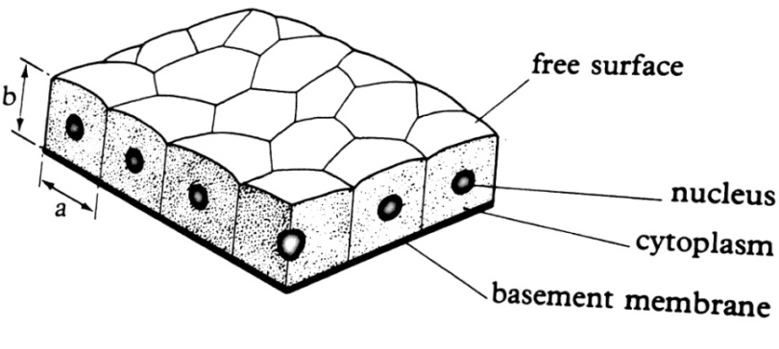

Distribution

* Lining of salivary ducts, pancreatic ducts, convoluted tubules and collecting ducts of the nephrons of the kidney
* Lining of the salivary glands, sweat glands and thyroid glands
* Lining of the retina

NB: The simple cuboidal epithelial tissue is non-secretory in the proximal convoluted tubule, distal convoluted tubule and pancreatic ducts.

The functions include: Protection, excretion, absorption and secretion

Adaptations

1. Cells are tightly packed together with little intercellular spaces between them to offer protection from injury and infection.
2. Possess many Golgi bodies which perform functions of secretion of hormones and enzymes.
3. Some possess microvilli which increase the surface area for example reabsorption of materials from the renal fluids in the kidney tubules.
4. Cells have numerous mitochondria for energy production to be used in active reabsorption of materials eg from renal filtrate back into the bloodstream.
5. Simple columnar epithelium

It is a single layer of column like narrow elongated cells at right angles to the basement membrane. Each cell possesses a nucleus situated at the basal end and it is oval in shape. The epithelium is often interspersed with goblet cells. The free surface of each columnar cell has microvilli forming a brush border.

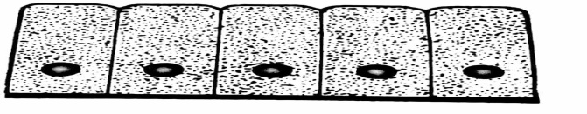

Distribution

* Lining of the stomach, small intestines, gall bladder, and kidney ducts.
* Lining of the gastric glands, intestinal glands, mammary glands, thyroid glands, salivary glands.

The functions include: Secretion, protection, absorption and the surface area is increased by having brush border (microvilli) at the cell free surface.

Adaptations

1. Possess fingerlike projections called microvilli which increase the surface area for absorption such as digested food in the intestines.
2. Possess mucus secreting cells which secrete mucus. The mucus protects the gastric walls from hydrochloric acid and digestive enzymes.
3. Mucus from goblet cells also lubricates the passage of food in the intestines.
4. Ciliated epithelium

Cells of this tissue are usually columnar in shape but bear numerous cilia at their free surfaces. The cells are usually associated with mucus secreting goblet cells.

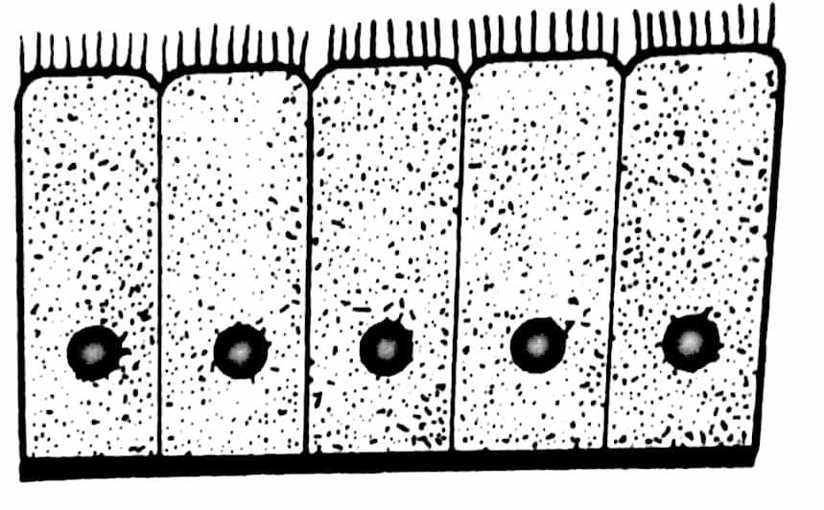

Distribution

* Lines the oviduct
* Ventricles of the brain, spinal canal and respiratory passages (trachea, bronchi and bronchioles)

Functions

* Mucus protects lining and lubricates the passage of materials.
* Cilia set up currents to move materials in a certain direction.

Adaptations

1. Interspersed with goblet cells which secrete mucus to protect the lining of the gut from enzyme and acidic action.
2. Possess cilia which set up currents that move materials from one direction to another.
3. Possess goblet cells which lubricate the passage.
4. Pseudostratified epithelium

This is a simple epithelium since all cells rest on a basement membrane, but some do not reach the free surfaces. This gives an appearance of the epithelium to be on different levels and the nuclei at different layers. Nevertheless, the epithelium is one layer of cells thick with each cell attached to the basement membrane.

Most cells are columnar, thus usually named pseudostratified columnar epithelium. Where the cilia appear at the free surface (trachea, bronchi, bronchioles), it is called pseudo stratified columnar ciliated epithelium.

Pseudo stratified epithelium also lines the urinary tract and ducts of large glands (non-ciliated pseudo stratified).

Pseudo stratified columnar

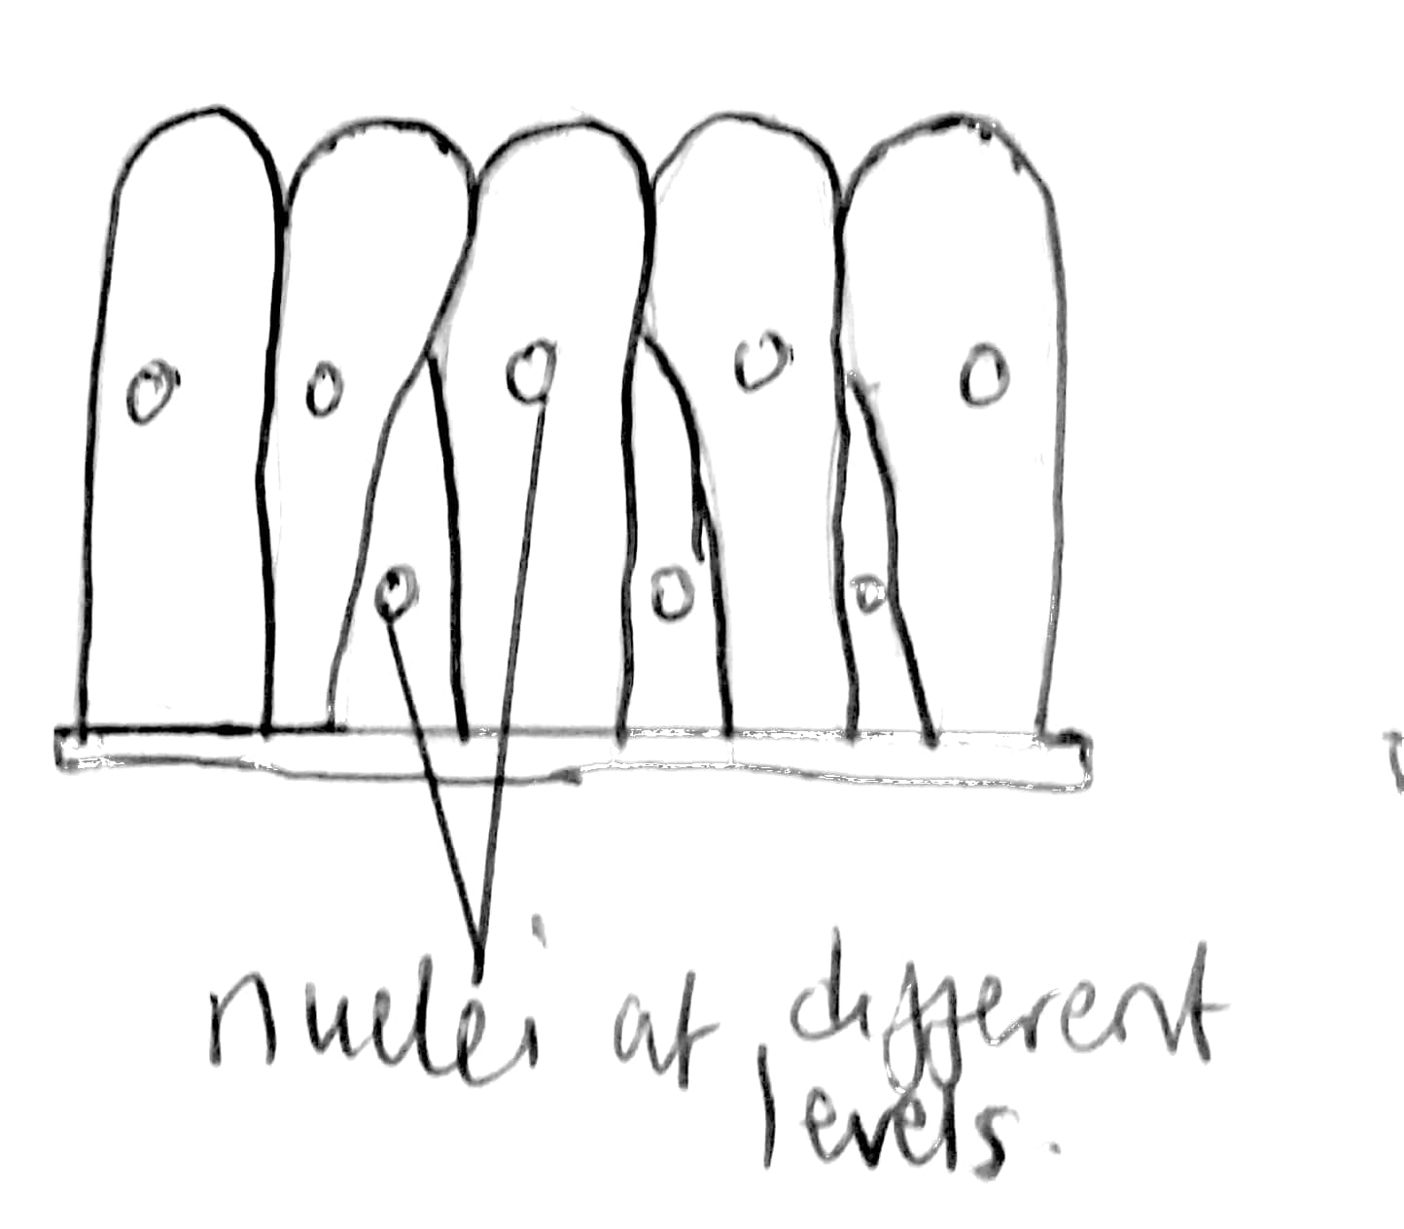

pseudo stratified columnar ciliated

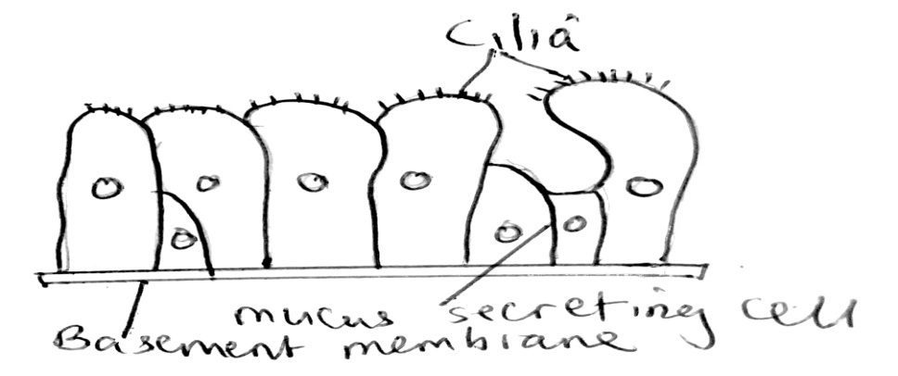

STRATIFIED EPITHELIA

Have more than one layer of cells with only the bottom layer resting on the basement membrane. These cells form the germinative layer and continue to divide by mitosis and push other areas outwards. They are primarily found in areas where the epithelium has protective functions.

1. Stratified squamous epithelium

The cells first formed on the basement membrane are cuboidal in shape, but as they are pushed outwards the free surface of the tissue, they become flattened and these cells are called squamous. It is the thickest of all epithelia and its function is protection.

The cells of the surface layer may have keratin (cornified) or lack keratin (uncornified). Keratin is a tough protective protein which prevents water loss, is resistant to friction and repels bacteria.

Non-keratinized stratified squamous epithelium lines wet surfaces subjected to abrasion such as lining of the mouth, oesophagus, part of the epiglottis and vagina. Keratinized stratified squamous epithelium forms the epidermis of the skin.

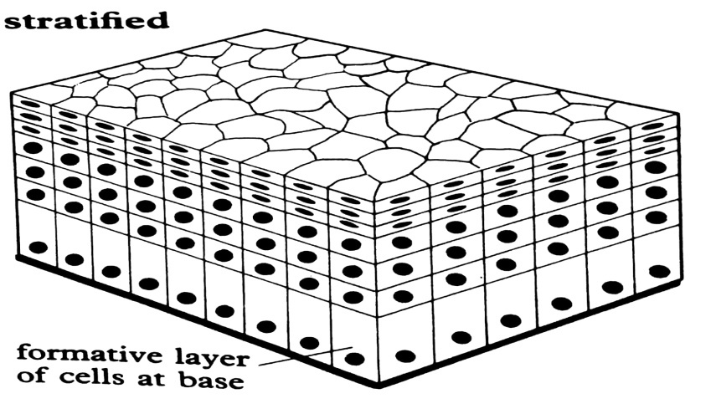

1. Stratified cuboidal epithelium

This epithelium has several layers of epithelial cells but the surface layer of this epithelium is composed of cuboidal cells. It is found in the largest ducts of sweat glands, mammary glands, salivary glands and in parts of the male urethra. Its role is protection and provides strength.

1. Stratified columnar epithelium

This epithelium has several layers of epithelial cells but the surface layer of this epithelium is composed of columnar cells. It is very rare. It lines parts of the urethra, larger ducts of some glands, portion of the conjunctiva of the eye. Its roles are protection and absorption.

1. Transitional epithelium

It comprises 3 to 4 layers of cells all of similar size and shape except at the free surface where they are more flattened. The cells do not slough off/flake off.

It is found in organs/structures which can expand like the bladder, guddles of women where they come back to normal after delivery, ureters and part of urethra. It allows for distension of the urinary organ.

Because the shape of the cells at the surface is transitory (changes depending on the degree of stretching of the organ), this epithelium is called transitional. It will look like a stratified squamous epithelium if it is stretched or stratified cuboidal epithelium if it is unstretched.

Adaptations of the transitional epithelium to its function

1. By changing its shape, the transitional epithelium allows expansion of the organ such as the urinary bladder. This increases the volume of the organ.
2. Transitional epithelium is composed of many layers of cells making it impermeable to water from blood to urine.
3. Due to its thickness, it prevents urine from escaping to the surrounding tissues.

Glandular epithelium

It is formed by epithelial cells which are frequently interspersed with secretory cells eg goblet cells or aggregates of glandular cells forming multicellular gland.

Illustration of glandular epithelium

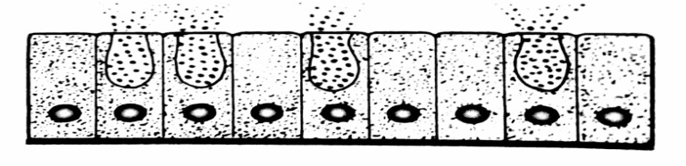

There are two types of glands.

* Exocrine glands where the secretion is delivered to the free surface via ducts.
* Endocrine glands- Secretions are released and passed into the bloodstream (ductless glands).

Based on the mode of secretion, the exocrine glands are of three types

1. Merocrine glands

Secretions produced by cells are simply passed through the cell membrane at the cell free surface without losing any of its cytoplasm. The cell therefore remains intact. Examples include; goblet cells, pancreatic glands, sweat glands.

1. Apocrine glands

Here, the glandular epithelia shed their secretion by the top part of the cell loaded with the secretion breaking away from the rest of the cell eg mammary glands. The cell loses part of the cytoplasm while releasing its secretion.

1. Holocrine glands

In this case, the whole secretory cell disintegrates and the secretions are from the epithelium eg the sebaceous glands of the mammalian skin.

An epithelium containing goblet cells is called a mucus membrane. Multicellular exocrine glands exist in various forms which include

1. Simple saccular/alveolar gland-located in the skin of frog and other amphibians

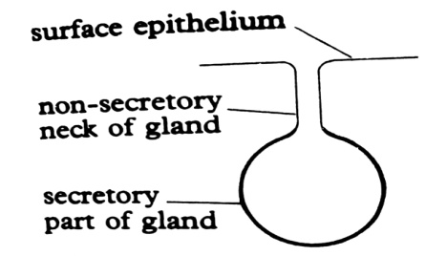

1. Simple tubular gland- found in the crypts of lieberkuhn in the walls of the mammalian small intestines.

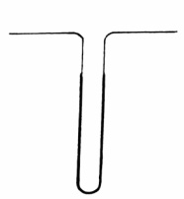

1. Coiled tubular gland- eg that found in the sweat glands in the skin of humans

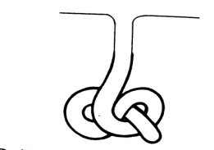

1. Simple branched tubular gland- eg brunner’s glands in the walls of the mammalian small intestines and gastric glands in the walls of the stomach.

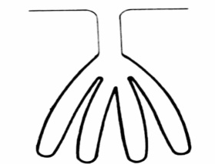

1. Simple branched saccular gland- eg the oil secreting sebaceous glands in the mammalian skin.

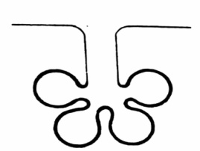

1. Compound tubular gland- eg the salivary glands

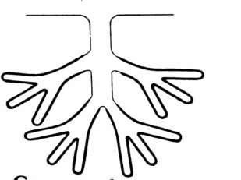

1. Compound saccular gland- eg part of the pancreas which secretes the digestive enzymes and mammary glands.

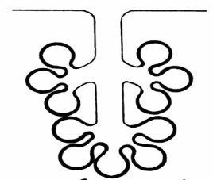

Functions of the epithelial tissue

1. Protection

Epithelial tissue basically protects the underlying tissue from injuries by chemicals, pressure abrasion and infection.

Adaptations of the epithelial tissue for protection

1. Columnar epithelium lining the stomach is interspersed with goblet cells which secrete mucus. The mucus protects the stomach lining from acidic contents of the stomach and from digestion by enzymes. Mucus also lubricates the passage of food thereby protecting the lining from abrasion.
2. The shorter cells of the pseudo stratified epithelium lining the trachea and bronchi secretes mucus which traps dust particles and bacteria in the inhaled air and the cilia on the longer cells beat expelling them in the outward direction.
3. Keratinized squamous stratified epithelium on external skin surfaces (epidermis) is highly resistant to mechanical damage due to cornification (addition of keratin) protecting the underlying tissue from abrasion.
4. The layers of the non-keratinized stratified squamous epithelium lining the pharynx and oesophagus are thick, protects the underlying tissue from mechanical damage by the food that is swallowed.
5. The many layers of the stratified cuboidal epithelium lining the salivary, pancreatic and sweat ducts protects them against mechanical stress.
6. The layers of the columnar cells of the stratified columnar epithelium lining the ducts of the mammary glands, protects them from mechanical and chemical injury.
7. Secretion

A number of epithelial cells are modified to produce secretions such as mucus, hormones etc.

Adaptations of epithelium for secretion

1. Cuboidal epithelium lining the salivary glands, sweat glands and thyroid gland secrete saliva, sweat and thyroxine respectively.
2. Columnar epithelium lining the stomach is interspersed with goblet cells which secrete mucus.
3. The stratified columnar epithelium lining the ducts of mammary glands secretes a fluid.
4. Excretion- The epithelial cells of the kidney tubules and sweat glands remove excessive and toxic metabolic wastes from the body thus helping the body in excretion.

Ciliated cuboidal epithelium lining parts of the nephron have cilia which beat to facilitate flow glomerular filtrate.

1. Absorption- Cuboidal and columnar epithelia are modified for absorption.

Adaptation of epithelia to absorption

1. Squamous epithelium lines the renal corpuscles of the kidney, the alveoli of the lungs and the blood capillary walls where its extreme thinness permits rapid diffusion of materials through it.
2. Cuboidal epithelial cells lining the proximal convoluted possess extensive microvilli forming a brush border of microvillus which increases the surface area for absorption of nutrients.
3. Exchange of materials and gases- Squamous epithelium is extremely thin and flattened promoting exchange of materials and gases by diffusion such as the alveoli of the lungs.
4. Sensory- epithelia bearing sensory cells and nerve endings are specialized to receive stimuli as in the skin and retina of the eye.
5. Movement of materials- Epithelia may be modified to aid movement of materials.

Adaptations of epithelia to move materials

1. Ciliated columnar epithelium lining the inside of the oviduct, ventricles of the brain, spinal canal and respiratory passages bears numerous cilia at their free surface. These are associated with mucus secreting goblet cells producing fluids in which the cilia beat up rhythmically setting up currents which move materials from one location to another.
2. Pseudo stratified epithelium lining the trachea and bronchi possess longer ciliated cells and shorter mucus secreting cells without cilia. The mucus traps bacteria, dust and other small particles preventing them from reaching the lungs.
3. Squamous epithelium lining hollow structures eg the heart chambers, blood vessels is flat and smooth allowing friction free passage of materials through them.

CONNECTIVE TISSUES

Connective tissues are derived from the embryonic mesoderm.

Functions of connective tissues

1. It binds the various tissues together like the skin with muscles and muscles with bones.
2. It is a packing tissue forming sheath like bags around the body organs.
3. Areolar tissue protects the body against wounds and infections.
4. Adipose tissue stores fats, and insulates the body against heat loss.
5. Connective tissue is the major supportive tissue of the body, composed of bones and cartilage which provides the body with a supportive framework.
6. Haemopoitic tissue produces blood.
7. Lymphatic tissue builds body immunity by producing antibodies.
8. Connective tissue separates the body organs, so that they do not interfere with each other’s activities.
9. Protects blood vessels and organs where they enter or leave organs.

Connective tissues occur in different forms which are divided into two major classes

* Connective tissue proper which is further divided into loose and dense connective tissues
* Special connective tissues which include; cartilage, bone and blood. Cartilage and bone form the skeletal tissue.

LOOSE CONNECTIVE TISSUES

They include areolar, adipose and recticular connective tissues

Areolar connective tissue

This is the most abundant type of connective tissue found all over the body beneath the skin, connecting organs together and filling spaces between adjacent tissues.

Areolar connective tissue consists of a gelatinous glycoprotein matrix or ground substance containing two types of protein fibres and four types of cells. The protein fibres include;

1. Collagen fibres

They are white fibres forming wavy bundles running parallel to each other and are not branched. They are flexible but inelastic (non-stretchable)

1. Elastic fibres

They are thin yellow fibres which are highly branched forming a network in the matrix. They are flexible and elastic. The main function of fibres is to give the areolar tissue its strength and toughness. It also allows the tissue to be flexible and elastic.

The cells within the matrix include;

1. Fibroblasts

These are flattened and spindle like shaped cells containing an oval nucleus. They are generally closely applied to fibres but migrate to the wounded tissue o secrete more fibres in that region that effectively seal off the injured area. The function of fibroblasts is to secrete fibres

1. Macrophages/histocytes

They are large cells capable of amoeboid movement for which reason; they are referred to as amoeboid cells. Their function is to engulf/ingest bacteria and other foreign particles. They are generally mobile but at times, they wonder to areas of bacterial invasion. Therefore, they serve to defend the body against diseases.

1. Mast cells

They are amoeboid cells which are oval shaped and contain granular cytoplasm. They are found in abundance close to blood vessels. They have the following functions

* Secretion of the matrix.
* Secretion of an anticoagulant, heparin.
* They secrete histamine, a substance attributed to the effects of allergy.

1. Fat cells

They are mainly filled by lipid droplets. They cytoplasm and nucleus of a fat cell are confined to the margins of the periphery.

Diagram of an areolar tissue (FA page 36)

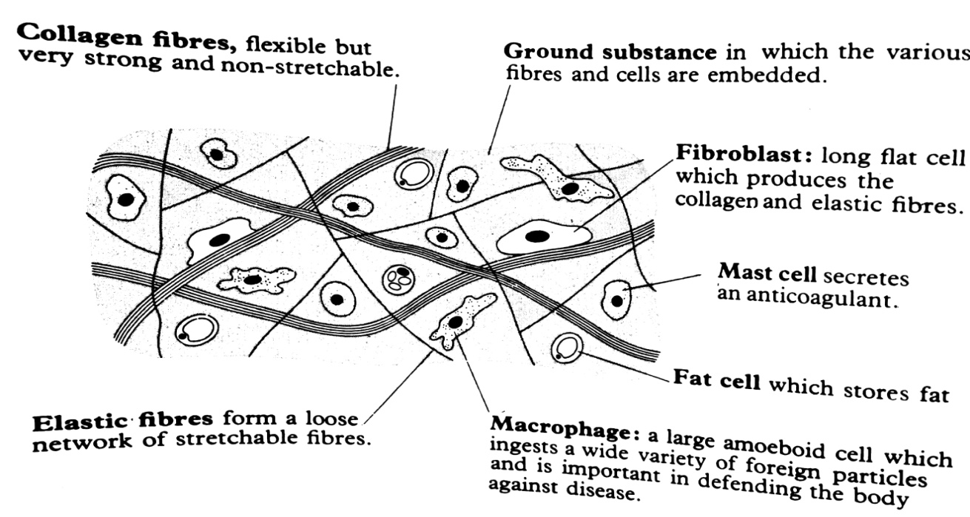

Areolar connective tissue is found in the skin and in most internal organs of vertebrates where it allows the organs to expand. It also forms the protective covering of muscles, blood vessels and verves.

Functions of the areolar connective tissue

1. Binds tissues and organs together.
2. Serves as a packing tissue filling spaces between adjacent tissues.
3. Support various tissues.
4. Provide tissues which resist strain and displacement.
5. Provides protection against wounds and infections.

Adipose tissue

It is a type of connective tissue with reduced matrix material and contains enlarged fat cells that are numerous in number. Adipose tissue functions to store energy, insulate the body and provides shock absorption to delicate mammalian organs eg the kidney. It also occurs beneath the skin, the buttocks. Adipose tissue occurs in two forms ie the white and brown adipose tissue.

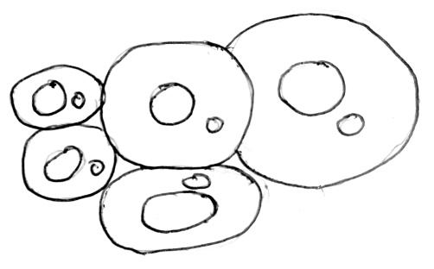

Recticular connective tissue

It contains an abundance of recticular fibres. It provides a supporting framework for organs such as those of the lymph nodes, spleen and the liver.

DENSE (FIBROUS) CONNECTIVE TISSUE (DCT)

DCT contains tightly packed collagen fibres making it stronger than the lose connective tissue. It consists of two types, regular and irregular

The collagen fibres in the dense regular connective tissue are oriented in one direction to provide strength in that direction. It is found in tendons and ligaments. Tendons connect muscles to bones, ligaments connect bone to bone.

Irregular dense connective tissue contains collagen fibres oriented in many different directions. It is found in deep layers of the skin and the tough capsules that surround many of the organs eg the kidney, adrenal glands, nerves, bones and covering of the muscles as epimysium and periosteum. It provides support and strength.

SPECIAL CONNECTIVE TISSUES

SKELETAL TISSUES

CARTILAGE/GRISTLE

This is a connective tissue consisting of cells embedded in a matrix called chondrin. The matrix is deposited by cells called chondroblasts and possess many fine fibres mostly collagen. Eventually, the chondroblasts become enclosed in spaces called lacunae. In this state, they are termed as chondrocytes.

The margin of a piece of cartilage is enclosed by a dense layer of cells and are fibrils called perichondrium in which new chondroblasts are produced and constantly added to the internal matrix of the cartilage.

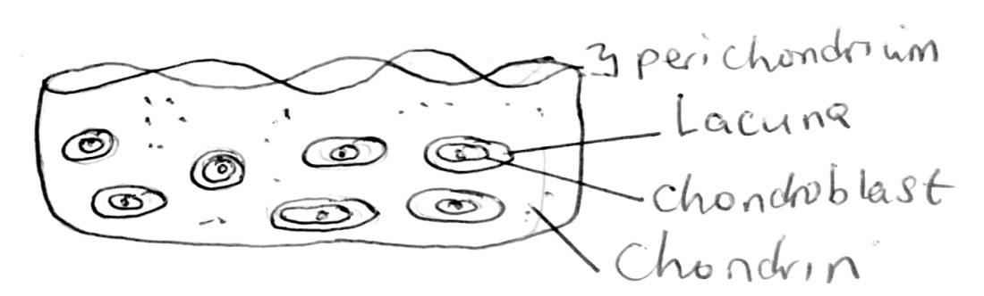

Cartilage is highly adapted to resist any strains that are placed on it. The matrix of cartilage is compressible and elastic. The collagen fibres resist any tensions which may be imposed on the tissue.

The cartilage in adults is restricted to the articular (joints) surfaces of bones that form freely moveable joints and other specific locations eg the nose, pinna, intervertebral discs, larynx, etc.

Types of cartilage

There are three types of cartilage each with the organic components of the matrix quite distinct. They include; hyaline cartilage, yellow elastic cartilage and white fibrous cartilage.

Hyaline cartilage

It is the simplest form of cartilage which is elastic and compressible. It mainly comprises a semitransparent matrix and chondrocytes. It frequently contains fine collagen fibrils. It has no processes extending from the lacunae into the matrix and neither are there blood vessels. Therefore, exchange of materials between the chondoblasts and the matrix is by diffusion.

It is located in the ends of the bones, in the nose and the wall of the trachea and bronchi. It also forms the embryonic skeleton in many vertebrates.

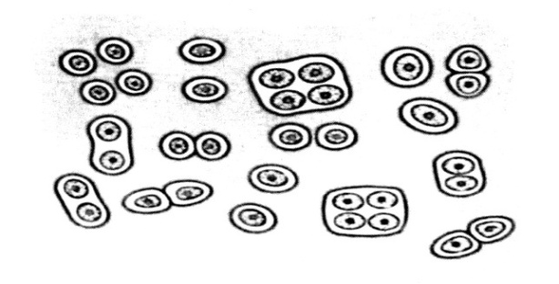

Yellow elastic cartilage

It has a semi opaque matrix containing a network of yellow elastic fibres. The fibres confer greater elasticity than found in the hyaline cartilage. Due to high elasticity and flexibility, the tissue quickly returns to its shape after distortion.

It is located in the external ear, in the epiglottis and cartilages of the pharynx

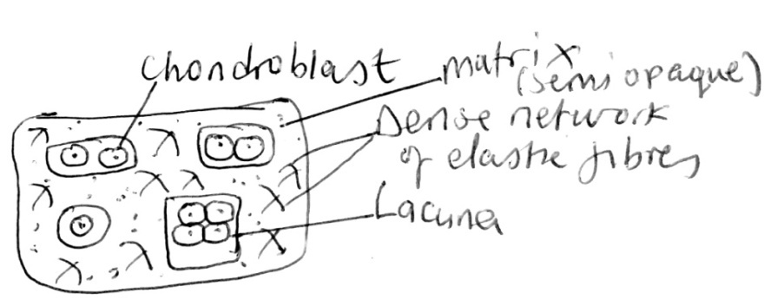

White fibrous cartilage

In addition to chondrocytes in the matrix, there are large bundles of densely packed collagen fibres. This gives the tissue a greater tensile strength than hyaline cartilage as well as a small degree of flexibility.

It is located in the discs between adjacent vertebrae which provide a cushioning effect and the ligamentous capsules surrounding the joints.

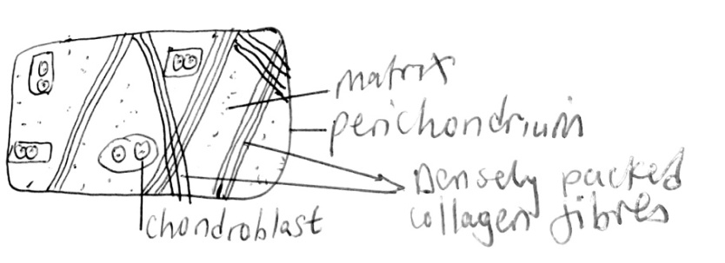

Adaptations of the collagen tissue to its function

* It is flexible but very strong and non stretchable allowing it to withstand the stresses of movement of connective tissues.
* It has a fibrous structure which allows it to bind structures together in connective tissues.

BONE

This is very abundant providing support, protection and some metabolic functions. The bone has an organic matrix containing collagen fibres, and is impregnated with small needle shaped crystals of calcium phosphate in form of hydroxyapatite which is brittle but rigid giving bone great strength. Calcium carbonate is also contained within the matrix.

A bone is a dynamic living tissue that is constantly reconstructed through the life of an individual by bone cells called osteoblasts. Osteoblasts secrete the matrix in which calcium phosphate is later deposited. After calcium phosphate has been deposited, the osteoblasts become less active and are now called osteocytes and are energized in spaces called lacunae.

Another type of bone cells called osteoclasts exist in thematrix which play a role in dissolving the bone matrix to enable further reconstruction of a bone during growth. A bone is constructed in thin concentric layers called lamellae which are drawn around narrow channels called haversian canalsthat run parallel to the bone length.

Haversian canals contain nerve fibres and blood vessels which keep the osteocytes alive. The concentric lamellae and the encircled canal are termed as the haversian system/osteon.

The lacunae have very many fine channels called canaliculi containing cytoplasm which link up with the central haversian canal, with other or press from one lamella to another. An artery and a vein run through the haversian canal and capillaries branch from here through the canaliculi. A haversian canal also contains lymph vessels and nerve fibres.Covering the bone is a layer of dense connective tissue called periosteum. The inner region of the periosteum has blood vessels and contains cells that can develop into osteoblasts and osteoclasts.

Part of the transverse section of a haversian system

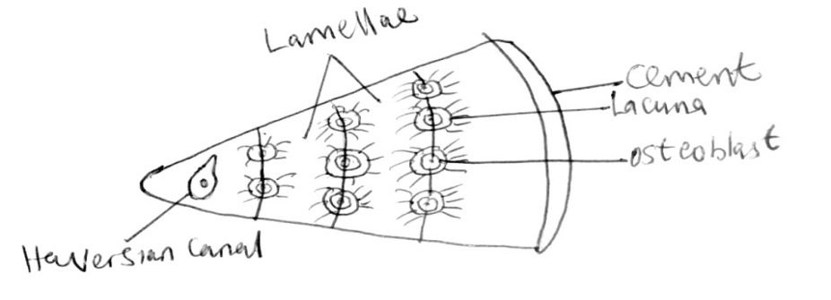

Types of bone

There are two types of bone ie compact/dense bone and spongy bone

Compact bone/dense bone

They are used in the growth of long bones and form the long shape of the bone between two swollen ends. The matrix of compact bones is composed of collagen and calcium phosphate, with quantities of magnesium, sodium, carbonate, nitrate ions. The combination of organic with inorganic materials produces a structure of great strength.

The lamellae are laid down in a manner that is suited to the force acting upon the bone and the load that has to be carried.

A transverse section of a compact bone

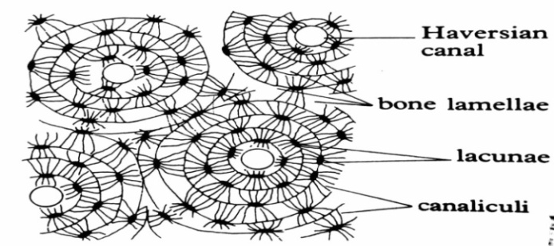

Longitudinal section of a compact bone

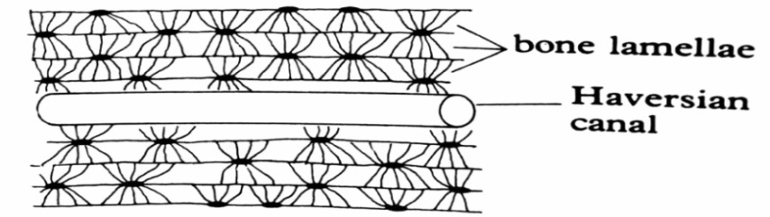

Spongy/cancellous bone

Spongy bone occurs within longer bones and is always surrounded by compact bone. Spongy bone consists of thin bars or sheets of bone called trabeculae, interspersed with large spaces occupied by the bone marrow.

The trabeculae contain osteocytes which are more or less irregularly dispersed in the matrix. The matrix contains rather a smaller proportion of inorganic material than does the matrix of the compact bone. The trabeculae develop along the lines of stress within the bone.

The spaces within the spongy bone at the head (epiphysis) of the long bones contain red bone marrow tissue. This very soft tissue is less dense than the bone, and is the site of red blood cell formation. Yellow marrow tissue, consisting principally of fat fills the spaces within the spongy bone of the shaft.

Spongy bone in section

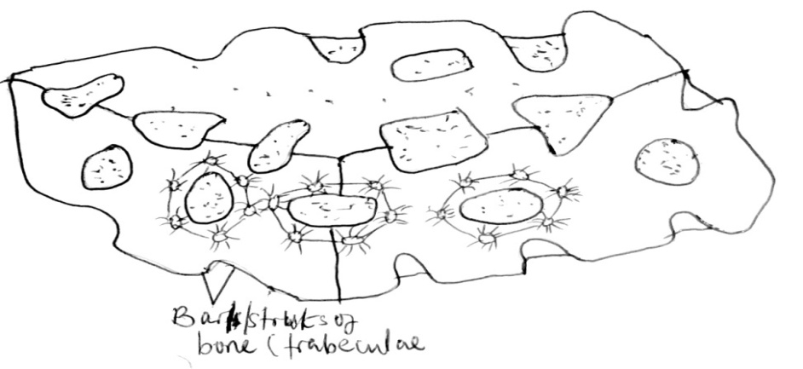

Long bone in section

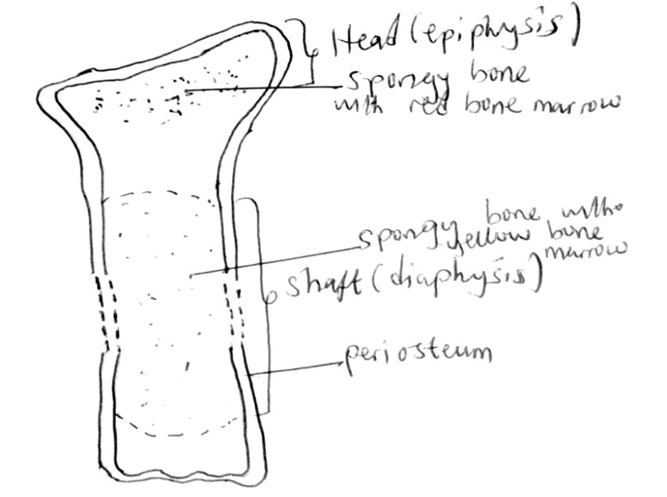

The development of bone (ossification)

Ossification is the process of formation and development of bone. A bone originates in two ways; intramembranous ossification and endochodral ossification.

Intramembranous ossification

The thin bony plates of the skull and parts of some other bones eg clavicles are formed directly by clusters of ossification which appears inside fibrous membranes. The strands of bone formed by different clusters are called trabecullae and become linked to form a loose network described as spongy bone. Thus spongy bone is formed by intramembranous ossification.

As development continues, remodeling of the skull plates converts some of the spongy bone to compact bone and allows the plates to reach their adult shape and size.

Endochondral ossification

Endochondral ossification is the process of replacement of cartilage by bone. The skeleton of the vertebral embryo consists of mainly hyaline cartilage. Each cartilage element is surrounded by a layer of dense connective tissue, the perichondrium

Ossification of bones (such the long bones of the arms and legs) begins when blood vessels penetrate the perichondrium of the cartilage midway along the shaft/diaphysis of the cartilage model.

This stimulates some of the cells of the cartilage perichondrium to become osteoblasts which produce a collar of compact bone in the shaft region. The layer of dense connective tissue now surrounding the developing embryo is called the periosteum.

A primary ossification centre appears inside the shaft and is progressively invaded by a proliferating number of blood vessels and osteoblasts. The matrix of the cartilage tends to become calcified by deposition of calcium and phosphate, but is eroded by the osteoclasts leaving spaces which eventually fuse to form the marrow cavity.

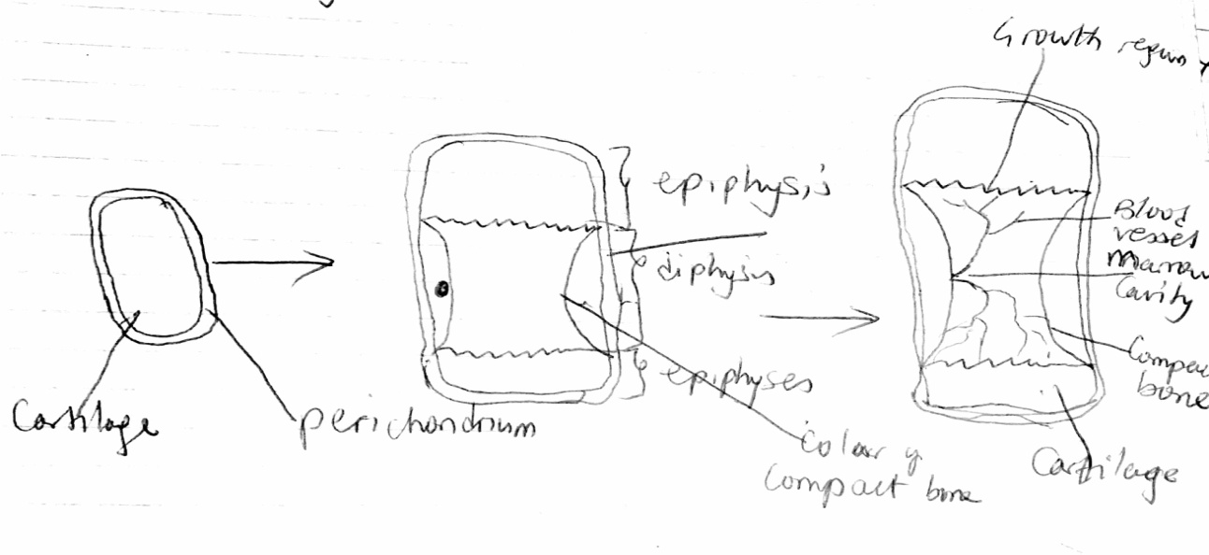

Working in small groups, osteoclasts tunnel through the bone leaving curvities which are invaded by blood capillaries and new bone forming osteoblasts. Within the tunnel, osteoblasts lay down a new bone matrix in concentric rings forming an arrangement called haversian system.

Cartilage continues to grow at either end producing an increase in length. Most of the cartilage is later replaced by a spongy bone.

In mammals, secondary ossification centres develop in the swollen ends/epiphyses of the cartilage models of long bones. The epiphyses ossify more or less completely except for a thin layer of cartilage called an epiphyseal plate, separating each epiphysis from the main shaft.

Increase in diameter of the bone shaft is achieved by continual remodeling and deposition of new bone by osteoblasts of the periosteum. As maturity approaches, the thickness of the epiphyseal plates is reduced and finally the epiphyses and the bone shaft fuse completely leaving a faint epiphyseal line. Ossification of all bones in human skeleton is normally completed by the age of 25.

Adaptations of bone to its function

1. A tough fibrous layer of dense connective tissue called periosteum provides a tough and hard covering that surrounds the bone and protects the inner cells.
2. Bundles of collagen fibres from the periosteum penetrate the bone giving more mechanical strength, providing an intimate connection between the underlying bone and the periosteum and acting as a firm base for insertion of tendons, which contribute to movement and locomotion.
3. Osteoblasts are arranged in concentric rings around a series of haversian canals in compact bone thus lay down the matrix in a similar rigid and dense regular pattern to provide uniform mechanical strength.
4. Bone lamellae contain numerous lacunae containing living bone cells called osteoblasts which secrete the matrix of the bone.
5. Mature less active osteoblasts called osteocytes can be reactivated quickly regaining the structure of active osteoblasts and depositing bone matrix, when structural changes in bone are required.
6. Bone cells are embedded in a firm bone matrix which is rendered hard by deposition of calcium salts and other inorganic ions.
7. Bone cells called osteoclasts responsible for dissolving of the matrix as it is laid down enable reconstruction and remodeling of the bone during endochondral ossification.
8. An artery, a vein and a lymph vessel pass through a haversian canal of a compact one allowing the passage of nutrients, respiratory gases and metabolic wastes towards and away from the bone cells.
9. Each lacuna has fine cytoplasmic extensions called canaliculi which pass through lamellae and make connections with other lacunae and with the central haversian canal, allowing communication between the lacunae in different lamellae, and with the central haversian canal.
10. Presence of numerous nerve fibres in the haversian canal allows co-ordination of bone reconstruction enabling each bone to adapt its structure to meet any change in mechanical requirement of an animal during its development.
11. Bone releases calcium and phosphate into the bloodstream as required by the body under the control of the hormones parathormone and calcitonin.
12. Spongy bone has spaces between the trabeculae, reducing the weight of the bone, allowing less restricted movement and locomotion.

Differences between a cartilage and bone

|  |  |
| --- | --- |
| Cartilage | Bone |
| No process extended from each lacuna into the matrix. | Lacuna possesses canaliculi that extend into the matrix. |
| No blood vessels and nerves in the tissue. | Blood vessels and nerves run through the haversian canal. |
| Exchange of material between chondrocytes occurs by diffusion. | Osteoblasts exchange materials by help of blood capillaries passing through the canaliculi into the lacunae. |
| Elastic and compressible | Relatively incompressible as the matrix is highly composed of minerals eg calcium ions, magnesium ions. |
| Matrix is relatively semitransparent with hyaline cartilage and semi opaque in yellow elastic cartilage. | Matrix is opaque |
| The matrix is not calcified. | Matrix is calcified with greater quantities of Mg2+, Na+, Ca2+ etc. |
| No concentric layers of lamellae and no haversian canals present. | Consist of concentric layers of lamellae surrounding the haversian canal. |
| Rather inactive. | An active tissue with metabolic activity. |
| Matrix secreting cells are called chondroblasts. | Matrix secreting cells are called osteoblasts. |
| It is differentiated into hyaline, white fibrous and yellow elastic cartilage. | It is structurally differentiated into compact and spongy bones |
| It is flexible due to relatively soft and flexible matrix called chondrin. | It is rigid due to solid matrix called osteon. |
| It is less strong. | It is stronger. |
| Chondroblasts are randomly scattered in the matrix and occur in singles, pairs or fours. | Osteoblasts are in concentric layers around the haversian canal. |
| It is mostly found in areas where cushioning is required. | It is located in areas where maximum support is needed. |

MUSCLE TISSUE

There are three types of muscular tissue which include: voluntary muscle, involuntary muscle and cardiac muscle.

Basic structure of a muscular tissue

1. All muscle fibres are made up of elongated and thin cells called muscle cells or muscle fibres.
2. The muscle fibres contain a specialized cytoplasm called sarcoplasm that contains a network of membranes called sarcoplasmic reticulum.
3. Muscle fibres may be bound by a cell membrane called sarcolemma.
4. Each muscle may contain numerous thin myofibrils.

SKELETAL/VOLUNTARY/STRIATED OR STRIPED MUSCLE

It is said to be striated because its muscle cells have transverse stripes when viewed in longitudinal section.

Distribution of skeletal muscles

It is found attached to the skeleton in the head, trunk and limbs hence the name skeletal muscle.

Gross structure of a skeletal muscle

The skeletal muscle is attached to a bone in at least two places namely; the origin, a fixed non-moveable part of the skeleton and the insertion, a moveable part of the skeleton.

Attachment is by a means of tough relatively inelastic tendons made up of almost entirely collagen fibres. At one end, the tendon is continuous with the outer covering of the muscle while the other end is of the tendon combines with the outer layer of the bone called periosteum and forms a very firm attachment.

The skeletal muscle is composed of bundles of muscle fibres each surrounded by a connective tissue, endomysium. Each bundle of muscle fibres is surrounded by perimysium, a connective tissue, the various bundles are surrounded by an epimysium, a connective tissue sheath.

Skeletal muscle showing the layers of connective tissue

Histology of a striated muscle (skeletal muscle)

The muscle is made up of many hundreds of long muscle cells called muscle fibres. Each muscle fibre is filled with a cytoplasm called sarcoplasm in which about 100 nuclei are spaced out evenly just beneath the bounding membrane called sarcolemma.

In the sarcoplasm, there are many thin myofibrils which possess characteristic cross striations. The myofibrils line up perpendicular with the cross striations next to each other. The myofibrils are composed of protein filaments called actin and myosin.

Fine structure of a striated muscle

Each myofibril is divided into light and dark bands. The light band has a comparatively light region in the middle called H- zone, and it has dark regions on either sides. In the middle of the H- zone is a dark line called the M- line.

Running through the light bands in the middle is the Z- line. The dark and light bands are called A and I bands respectively. I means isotropic, as it allows light to pass through and so appears lighter. A means anisotropic as it does not allow light to pass through, so it appears darker.

The region of a myofibril between two Z-lines is called a sarcomere and is described as the functional basic unit of a myofibril. Alternating light and dark bands are due to two types of protein filaments which run longitudinally. These are the thin actin and thick myosin protein filaments. The thick myosin filaments are confined to the dark band and the thin actin protein filaments occur in the light band but extend in between the thick myosin filaments within the dark band.

The segments on either side of the H- zone are due to both thick myosin and thin actin filaments overlapping. The H-zone consists only thick myosin protein filaments. The thin actin filaments alone are found in the light band.

Within each muscle fibre, there is an internal membrane system, the sarcoplasmic reticulum surrounding the myofibrils. The sarcoplasmic reticulum includes a system of transverse tubules (the T- system) which run into the muscle fibre from the sarcolemma at positions corresponding to the Z- lines.

Connected with the T- system are vesicles containing calcium ions in high concentration. Ca2+helps in hydrolysis of ATP. After muscle contraction, calcium ions are actively removed into the longitudinal tubules thereby lowering the concentration to a level below that at which ATP hydrolysis can occur.

Diagram of a myofibril to show the transverse and longitudinal tubules of the sarcoplasmic reticulum (FA page322)

There are four blood capillaries surrounding each muscle fibre. Each branch of the axon terminates at a plate like structure called neuromuscular junction. The motor end plate forms the neurone-to-muscle synapse, the connection between the motor neurone and the muscle fibre.

All the muscles served by the same motor neurone are called motor unit because they work as a unit contracting and relaxing at the same time. The motor unit is the basic functional unit of a skeletal muscle.

Actin and myosin filaments

Actin filaments

This consists of a fibrous protein (F- actin) together with two accession proteins, tropomyosin and troponin, both of which are globular.

Tropomyosin forms 2 helical strands around the F- actin in a longitudinal section. This arrangement brings about relaxation and contraction of the muscle. Troponin binds to the tropomyosin and calcium ions.

Myosin filament

It consists of two distinct regions, a long rod shaped region called a myosin rod, and a myosinhead. When a muscle is at rest, the tropomyosin blocks the sites to which myosin attaches. When calcium ions are released from the sarcoplasmic reticulum, they bind to troponin causing the tropomyosin to move away from the myosin binding site.

When excitation of muscles by nerve impulses stops, Ca2+ are pumped back into the sarcoplasmic reticulum and the muscle relaxes.

The sliding filament hypothesis of muscle contraction

The theory proposes that during muscle contraction, the thick and thin actin filaments slide past each other leading to shortening of sarcomeres.

The dark bands/A- bands remain the same length, and the light bands (I- bands) and the H- zone get shorter, then the Z- lines move closer together.

In the absence of calcium ions, tropomyosin blocks access of myosin heads to the binding site of an actin filament. When a nerve impulse through a motor neurone arrives at the neuromuscular junction at the surface of the muscle fibre, the action potential at the motor end plate is propagated through the transverse tubules to the vesicles. This causes the release of calcium ions from the vesicles down their concentration gradient in the sarcoplasm.

The calcium ions bind to troponin forming a calcium troponin complex. The positions of troponin and tropomyosin are altered such that the myosin head has access to its binding site on the fibrous actin (F- actin) forming actomyosin.

Myosin hydrolyses ATP in presence of ATPase enzyme on myosin head and undergoes conformational changes into a higher energy state. The myosin head binds into actin forming a cross bridge between the actin and myosin filaments.

Each bridge detouches itself from the thin filaments and retouches itself to another site further along, and the cycle of cross bridge formation is repeated through a chain of ratchet mechanism leading to muscle contraction.

When calcium ion level decreases, troponin blocks tropomyosin in the blocking position and actin filament slide back to their respective state.

Diagrams illustrating the mechanism by which actin filaments slide past the myosin filaments

After each bridge has completed its movement, it detouches itself from the thin filament and reattaches to another site further along the actin. The cycle is repeated at 50- 100 times per second.

The combined movement of many bridges has the effect of pulling the thin filaments past the thick ones resulting in contraction of the muscle. Contraction of the muscle is said to be brought about by the bridges going through a kind of ratchet mechanism as illustrated in the diagram below.

Diagram summarizing the proposed ratchet mechanism during muscle contraction

Diagrams from the electron micrographs confirming the sliding filament theory

Stretched/relaxed myofibril

Contracted myofibril

On contraction

* Length of the dark band/A- band/anisotropic band remains the same.
* Length of the light band/I band/isotropic band shortens.
* Length of the H-zone shortens.
* Length of the dark ends of the dark band increases.
* Overall length of the myofibril shortens.

NB: When the muscle is severely contracted, the ends of the thin filaments may touch the M- line and the H-zone disappears. In that condition, the filaments (thick and thin) uniformly overlap in the whole length of fibres.

Transverse section of the H-zone Transverse section of the end of the dark band

Transverse section of the light band

Q Describe the mechanism of muscle contraction

Arrival of the impulse at the neuromuscular junction depolarizes the presynaptic membrane and increases its permeability to towards calcium ions. This leads to diffusion of calcium ions from the synaptic cleft into the synaptic knob via the presynaptic membrane.

Ca2+ induces the synaptic vesicles to fuse with the presynaptic membrane and release the neurotransmitter substance eg acetylcholine into the synaptic cleft by exocytosis. Acetylcholine settles on the receptor sites of the post synaptic membrane and induces the post synaptic membrane to open the sodium channels. Sodium ions rapidly diffuse through the synaptic cleft into the sarcoplasm.

This depolarises the post synaptic membrane until a wave of depolarization moves across the sarcolemma to the T-system of the sarcoplasmic reticulum. The vesicles connected to the transverse tubules are stimulated to secrete calcium ions into the sarcoplasm.

Ca2+ combines with troponin to form calcium troponin complex which leads to a conformational change in the structure of tropomyosin such that it vacates/leaves the active sites of the actin filament. Myosin heads bind on the sites to form actomyosin. This activates ATPase enzyme on the myosin head to catalyse the hydrolysis of ATP into ADP and energy is released.

This energy is used by the myosin heads to bend away from 900C to 450C thereby pulling the actin filament inwards towards the centre of the sarcomeres while sliding past the stationary myosin filament. This causes the following changes;

* Decrease in the length of the H- zone.
* Decrease in the length of the sarcomere.
* Decrease in the length of the I- band.
* Increase in the length of the dark ends of the A- band.

ATP molecules attach on the myosin heads to provide them with energy to detouch themselves from the sites and reattach at another site and continue to pull the actin filaments until maximum contraction.

Muscle relaxation

When the muscle is no longer stimulated by an impulse/wave of depolarization, calcium ions are pumped back into the sarcoplasmic reticulum using the calcium pump and energy from hydrolysis of ATP until its concentration fall below the contractile threshold in the sarcoplasm. This results into detouchment of the myosin heads from the actin binding site using energy from the hydrolysis of ATP to ADP.

The actin filaments revert to their original position and tropomyosin reoccupies the actin binding site. The length of the sarcomere, I- band and H-zone increase back to their original and that of the dark regions of the dark band decrease back to their original position.

Adaptation of skeletal muscle tissue for its function/relationship between structure and function of a striated muscle

* It consists of elongated fibres, allowing considerable contractile length.
* Its fibres are parallel to give it maximum contractile effect and to allow each fibre to be controlled individually which gives ability to vary the length of the whole muscle contraction necessary for proper control of skeletal movement.
* The ends of the muscle fibre are tapered and interwoven with each other to provide adequate mechanical strength during muscle contraction.
* Its cells contain a large number of mitochondria to provide large amounts of ATP for muscle contraction.
* In their arrangements, the actin and myosin filaments fit into each other to allow them slide over each other to cause contraction.
* The cells have a rich blood supply to provide adequate supply of oxygen and nutrients.
* The muscle cells have myoglobin to store oxygen and release it for respiration when blood oxygen levels are low.
* Has a specialized region called the motor end plate where the axon of a motor neurone divides and forms fine non myelinated branches (dendrites) ending in synaptic knobs running in shallow troughs on the sarcolemma allowing nervous stimulation and control of the muscle.
* The sarcolemma folds inwards and forms a system of tubes called the T- system (transverse tubules) which run parallel through the sarcoplasm to the Z- lines allowing a nerve impulse arriving along a motor neurone at the neuromuscular junction at the surface of a muscle fibre to be propagated as a wave of depolarization (action potential) through the T- system causing release of calcium ions of the sarcoplasmic reticulum to activate the process of muscle contraction.
* The specialized endoplasmic reticulum of the muscle fibre called the sarcoplasmic reticulum forms the vesicles at the Z- line of the sarcomeres which contain calcium ions used to activate the process of muscle contraction.
* Ability to generate ATP using phosphocreatine during anaerobic conditions for a constant supply of ATP in the muscle.
* Ability to respire anaerobically for continued muscle contraction in anaerobic conditions.

VISCERAL/INVOLUNTARY/UNSTRIATED/UNSTRIPED/SMOOTH MUSCLE

* It consists of muscle cells called muscle fibres which are spindle shaped and tapering at both ends and uninucleated.
* The nucleus is single, elongated in shape, centrally placed and surrounded by little sarcoplasm.
* The muscle fibres lack a sarcolemma.
* Each muscle fibre consists of numerous inconspicuous, fine contractile myofibrils arranged longitudinally.
* The actin and myosin filaments are evenly distributed hence there are no striations or light and dark bands.
* Smooth muscle fibres are shorter than striated muscle fibres.
* Has sarcoplasmic reticulum but less extensive than in striated muscle.
* Has rings of smooth muscle fibres called sphincter muscle fibres for example; pyloric, cardiac and anal sphincters.
* Has prominent mitochondria but less numerous than in striated muscle.

Innervations and activity of the smooth muscle

* Smooth muscle is involuntary in action, so cannot be moved by ones will.
* Innervated by two sets of nerves from the autonomic nervous system (sympathetic and parasympathetic).
* Smooth muscle fibres undergo prolonged and slow, sustained rhythmical contractions and relaxations as in peristalsis, hence fatigues slowly.

The smooth muscle is located in the tracts of the intestines, genitals, urinary and respiratory systems and the walls of blood vessels

Functions of the smooth muscle

1. The anal sphincter controls the elimination of feaces from the body.
2. The pyloric sphincter controls passage of food from the stomach to the duodenum.
3. Small sphincter muscle surrounds some blood vessels to control the distribution of blood and regulation of blood pressure.
4. Control movement of materials with the body visceral organs.

CARDIAC MUSCLE

It is found only in the heart.

The structure of a cardiac muscle

A cardiac muscle consists of a network of interconnected cells called cardiac muscle fibres. Each muscle fibre is short, cylindrical and branched. Each muscle fibre possesses one large mitochondrion, with one nucleus or two nuclei, abundant cytoplasm, glycogen granules, well developed T system and poorly developed endoplasmic reticulum consisting of a network of tubules.

Cardiac muscle fibres are terminally branched and connected to each other by intercalated discs. Actin and myosin filaments are regularly arranged to give faint but regular cross striations. Muscle fibres branch and cross connect with each other to form a complex netlike arrangement.

Illustrations of the structure of a cardiac muscle (FA page 171)

Innervations and functioning of the cardiac muscle

* Cardiac muscle is myogenic meaning that the contractions are developed within the muscle.
* The rate of contraction can be influenced by the autonomic nervous system.
* Interconnections between the fibres (intercalated discs) ensure a rapid and uniform spread of the excitation.
* Have rhythmic rapid contractions and relaxation with a long refractory period and so do not fatigue as contraction is not sustained.
* Need a constant supply of large amounts of energy.
* A small number of cardiac muscle fibres and a few nerve endings form the Sino atrial node (SAN) located near the opening of the vena cava which stimulates heart beat on their own.

Adaptations of the cardiac muscles to their function

1. Cardiac muscle cells are highly branched terminally and connected to each other by intercalated discs to form a network that allows rapid spread of waves of electrical excitation from cell to cell, so that linked muscle cells rapidly contract rhythmically and simultaneously for fast heartbeat.
2. Dense network of blood capillaries ensures adequate supply of oxygen and food nutrients, for fast production of adequate ATP, for continuous rapid muscle contraction and rapid excretion of carbon dioxide and other metabolic wastes.
3. Numerous large mitochondria and glycogen granules rapidly provide adequate amounts of energy in form of adenosine triphosphate (ATP) by aerobic respiration for rapid contraction without fatigue.
4. Has the Sino atrial node (SAN) which emits waves of electrical excitation that initiate continuous and rhythmic contraction without fatigue, for continuous heartbeat.
5. Have striations for mechanical strength to support its fast and continuous contractions.
6. Undergoes rapid rhythmic contractions and relaxations with long refractory periods and thus does not fatigue as contraction is not sustained.
7. Well-developed T-system for rapid transmission of impulses thus rapid contraction and relaxation.
8. Branched muscle fibres offer a large surface area for fast spread of waves of electrical excitation for continuous contraction hence continuous heartbeat.

A comparison of voluntary, involuntary and cardiac muscles (similarities and differences)

|  |  |  |  |
| --- | --- | --- | --- |
| Feature | Striated muscle | Smooth muscle | Cardiac muscle |
| Names | Striated, striped, voluntary muscle | Unstriated, unstriped, smooth, involuntary, non-striated muscle | Heart muscle, cardiac muscle |
| Specialization | Most highly specialised | Least specialised | More specialised that smooth muscle |
| Shape | Elongated, cylindrical and unbranched muscle fibres. | Spindle shaped muscle fibres with tapered ends. | Elongated cylindrical and branched muscle fibres. |
| Arrangement | Arranged in bundles. | Arranged in bundles, sheets or rings. | Interconnected to form a network. |
| Nucleus | Multinucleated myofibrils with peripherally located nucleus. | Uninucleated myofibrils with centrally located elongated nucleus. | One or two nuclei in between intercalated discs. |
| Cytoplasmic contents | Numerous mitochondria in rows at the periphery and between fibres. | Prominent but less mitochondria. | Numerous large mitochondria |
| Prominent smooth endoplasmic reticulum forming a network of tubules. T- System well developed. | Individual tubules of smooth endoplasmic reticulum. | Poorly developed SER consisting of a network of tubules. |
| Glycogen granules and some lipid droplets. | Glycogen granules present. | Glycogen granules present. |
| Blood supply | Rich blood supply. | Poor blood supply. | Rich blood supply. |
| Striations or bands | Striations of light and dark bands | No striations or bands. | Faint regular striations present. |
| Intercalated discs | Absent | Absent | Present |
| Myofilaments/  Myofibrils | Very conspicuous | Inconspicuous | Conspicuous |
| Innervations | Under control of the voluntary nervous system. | Under control of the autonomic nervous system. | Myogenic, but rate of contraction can be influenced by the  autonomic nervous system. |
| Contractions | Powerful rapid contraction with short refractory period (rest period). | Shows sustained slow and rhythmic contractions and relaxation with a long refractory period. | Continuous rapid rhythmical contraction and relaxation with long refractory period hence contraction not sustained. |
| Fatigue | Fatigues quickly and easily. | Does not fatigue easily. | Does not fatigue. |
| Location | Attached to the skeleton in the head, trunk and limbs. | In the walls of intestines of genital, urinary and respiratory tracts, in walls of blood vessels. | Only in the walls of the heart. |
| Energy | Large amount of energy needed at once. | Much energy needed but constant supply required. | Needs a constant and good energy supply. |
| Sarcolemma | Present | Absent | Present |
| Mode of working | Voluntary | Involuntary | Involuntary |

NERVOUS TISSUE

It contains densely packed nerve cells called neurons which are specialized for conduction of nerve impulses. The neurons are the basic functional units of the nervous system.

Types of neurons/nerve cells

* Sensory/afferent neurons:- These conduct impulses from the receptors to the central nervous system.
* Motor /efferent neurones:- These conduct impulses from the central nervous system to the effectors.
* Relay/intermediate neurons:- These transmit impulses from the sensory neuron to the motor neurone. They are only found in the central nervous system.

Diagram of a motor neuron

Diagram of a sensory neuron

Diagram of a relay neuron

NB: The process which brings impulses towards the cell body is called a Dendron and the one which conducts impulses from the cell body is called the axon

Assignment Compare the structure of a motor neurone and a sensory neurone

Structure of a neuron

Each neuron posses a cell body and cytoplasmic extensions (nerve fibers’). Each cell body contains a nucleus and abundant granular cytoplasm. The cytoplasm also contains prominent conical granules called Nissl’s granules which are groups of ribosomes and rough endoplasmic reticulum rich in RNA and associated with protein synthesis.

From the cell body, extends out two types of cytoplasmic extensions; a Dendron and axon. Depending on the number and arrangement of these processes, the neurons are said to be unipolar, pseudounipolar and multipolar.

Unipolar:- It is a neuron with the axon as the only large branch from the cell body eg arthropod motor neuron

Bipolar neuron:- It is one where two processes, an axon and a Dendron project from the cell body. Examples of bipolar neurons are found in the retina of the mammalian eye.

Multipolar neuron:- It is one which has one axon and several dendrons from the cell body. An example is the motor neuron

Pseudounipolar:- It is where the cell body is not found along the axis/end of the axon. Instead, it is connected by a short side branch of the axon eg sensory neuron

PLANT TISSUES

1. MERISTEMATIC TISSUE

It is a plant tissue consisting of actively dividing cells which give rise to cells that differentiate into new tissues of the plant.

Meristem

A meristem is a group of cells which remain with the ability to divide by mitosis producing daughter cells which grow to form the rest of the plant body.

Types of meristems

Apical meristems:- They are found at the shoot tip and root tip. They divide continuously by mitosis leading to primary growth of the plant body that is increase in length of the shoot or root.

Lateral meristems (cambium):- They are responsible for secondary growth of the shoot and root ie increase in girth. They include the vascular cambium which gives rise to secondary vascular tissue including secondary xylem and phloem. They also include the cork cambium (phellogen) which gives rise to cork (phellem) which replaces the epidermis.

Intercalary meristems:-

* They allow growth in length in regions other than the root and shoot tips.
* Ensures continued growth where tissues are damaged such as when eaten by herbivores in grasses.

SIMPLE PLANT TISSUES

They are tissues consisting of one type of cell. They include the parenchyma, collenchyma and sclerenchyma

1. PARENCHYMA

It consists of living cells which are relatively undifferentiated. The cells are either roughly spherical or elongated. The cells have thin cell walls made up of cellulose, pectins and hemicelluloses. The cells also have large sap vacuoles with dense but peripheral cytoplasm.

Parenchyma tissue is located in the cortex, pith and medullary rays of wood. It also serves as a packing tissue in xylem and phloem

Functions of the parenchyma tissue

1. Acts as a packing tissue ie cells of the parenchyma fill spaces between other specialized tissues eg in the cortex, pith, between the xylem vessels and phloem.
2. It contains intercellular air spaces which allow gaseous exchange.
3. When they are turgid, parenchyma cells become closely packed thus provide support for the organs in which they occur. For example in the leaves and in stems of herbaceous plants.
4. It is a storage tissue due to possession of starch granules and large food vacuoles. Therefore, the tissue is abundant in storage organs eg the Irish potato.
5. It allows transportation of materials through cells by symplast pathway or apoplast pathway.
6. The parenchyma tissue is metabolically active as it is composed living cells for example some parenchyma are photosynthetic.
7. Growth of the pericycle in the roots where it retains the meristematic activity producing lateral roots and contributing to secondary growth.
8. In the endodermis, cells are covered by a fatty substance (suberin) that forms the casparian strip that prevents apoplast transportation of water through the root.

Transverse section of a parenchyma tissue

Relationship between structure and function of the parenchyma tissue

1. The cells are unspecialized to perform a variety of functions.
2. Many intercellular spaces to allow diffusion and exchange of gases.
3. Thin cellulose cell walls to allow passage of materials for transport.
4. Transparent cell walls to allow light penetration for photosynthesis.
5. The cells are large and contain large vacuoles with a thin layer of cytoplasm to provide storage space for materials of the plant.
6. Have isodiametric, roughly spherical or elongated cells to serve as a packing material between specialized cells.
7. Cells have permeable walls to allow entry of light for photosynthesis.
8. Cells have leucoplasts such as amyloplasts to store food such as starch.
9. Cells have chloroplasts to allow photosynthesis.
10. Cell walls contain cellulose, pectins and hemicelluloses for support.
11. The cells have chromoplasts such as in petals to provide bright colour to attract insects for pollination.

Modified parenchyma

They include; epidermis, mesophyll, endodermis, pericycle, companion cells and transfer cells.

1. Epidermis/epidermal cells

It is a layer of one cell thick that covers the whole primary plant body.

Functions

* The basic function is to protect the plant body from desiccation and infection. This is achieved by secreting cutin and forms the cuticle that is impervious to water.
* Specialized epidermal cells (the guard cells) bound/guard the stomata and are important in opening and closing of stomata.
* Hair like structures on cuticle (epidermis) serve various purposes./ for example, root hairs increase on the surface area for absorption of water and mineral salts by the roots.
* Hooked hairs of climbing stems prevent them from slipping off their supports.
* Glandular cells on the cuticle secrete sticky substance that traps and kills insects and they may also secrete scent.
* The epidermal hairs of leaves reduce water loss from the plant as well as reflecting the sun’s radiations.
* Being transparent, the epidermis allows passage of light in the mesophyll cells for photosynthesis.
* The epidermis may develop hairs which form a barrier around the nectories of flowers preventing access to crowling insects and promoting cross pollination.

Q State the various modifications of the epidermis to serve different functions

1. Mesophyll cells (chlorenchyma)

Mesophyll is a packing tissue located between the upper and lower epidermis of leaves. There are two types of mesophyll cells.

* Palisade mesophyll cells- They are located in the upper layer called the palisade mesophyll layer. Cells are elongated and columnar in shape. They contain a large number of chloroplasts. The cells are tightly packed with very few and narrow air spaces.
* Spongy mesophyll cells- They are located in the lower layer called the spongy mesophyll layer. Cells are spherical and irregularly shaped with fewer chloroplasts. They possess large intercellular air spaces between the cells.

The functions of the mesophyll include: photosynthesis, gaseous exchange and Storage of starch

Adaptations of the mesophyll to its function

1. Palisade mesophyll cells are column shaped with numerous chloroplasts in a thin layer of cytoplasm to carry out photosynthesis.
2. Palisade mesophyll cells are tightly packed together forming a continuous layer that traps incoming light.
3. The chloroplasts within the mesophyll cells can move towards light allowing them to be in the best positions to receive light.
4. Chlorophyll within the chloroplasts is contained within the grana, where it is arranged on the sides of a series of unit membrane allowing chlorophyll to receive maximum light.
5. The structural arrangement of chlorophyll on the photosynthetic membrane brings chlorophyll in close proximity to other pigments such as carotenoids and enzymes necessary for its functioning in light harvesting.
6. Spongy mesophyll cells are irregularly shaped hence fit together loosely leaving large air spaces to allow efficient gaseous exchange via the stomata.
7. The mesophyll cells contain numerous amyloplasts for storing starch.
8. Endodermis

It is the inner most layer of the cortex surrounding the vascular tissue of the roots and stems. It consists of living, elongated and flattened cells. The cell wall of endodermal cells comprises cellulose, pectins, hemicelluloses and deposits of suberin

Functions of the endodermis

* Acts as a selective barrier to movement of water and mineral salts between the cortex and xylem in roots.
* In dicot stems, it stores starch forming a starch sheath with a possible role in the gravity response of stems.

Adaptations of the endodermis to its functions

* The endodermis of roots has the casparian strip (made up of suberin) which is impermeable to water and prevents water and solutes from flowing through the air spaces of the cell walls of the endodermal cells (apoplast pathway). This forces water through the cell surface membrane into the cytoplasm of the endodermal cells, hence allowing the endodermal cells to regulate the movement of solutes through the xylem.
* Active pumping of salts by endodermal cells into the xylem allows rapid movement of water by osmosis into the xylem leading to a buildup of root pressure.
* Control of movement of water and solutes by endodermal cells acts as a protective measure against the entry of pathogens and toxic substances into the xylem.
* In dicots, the endodemal cells contain amyloplasts for storing starch grains forming a starch sheath.

1. Pericycle

It is a layer of modified parenchyma, one to several cells thick, located in roots between the central vascular tissue and the endodermis. It consists of one to several layers of living, roughly spherical and elongated cells. Their cell walls are composed of cellulose, pectins and hemicelluloses.

Functions of the pericycle

* Produces lateral roots.
* Contributes to secondary growth

Adaptations of the pericycle to its function

* It retains its capacity for cell division (meristematic activity) to produce lateral roots.
* Due to its meristematic activity, it contributes to secondary thickening of the roots.

1. Companion cells

They are specialized parenchyma cells found adjacent to the sieve tubes.

They have a prominent nucleus, dense cytoplasm with numerous small vacuoles, plastids and the usual cell organelles. They are metabolically very active with numerous mitochondria and ribosomes. Each companion cell is connected to a sieve element by plasmodesmata.

Functions of the companion cells

* Control of the activity of the adjacent metabolically inactive sieve tube elements.
* Provide energy needed for the active processes which occur during translocation of organic solutes in the sieve tubes

Adaptations of the companion cells to their function

* Plasmodesmata connect sieve elements with companion cells allowing communication and exchange of materials between companion cells and sieve tube elements.
* Companion cells have large nucleus to effect metabolic activity over both companion cells and sieve tubes.
* Companion cells contain numerous mitochondria to produce energy for active transport of materials in the sieve elements.

1. Transfer cells

They are modified form of parenchyma companion cells found next to the sieve tube. They have numerous internal projections of the cell wall formed by extra thickening of the cell wall. They posses numerous mitochondria in the dense cytoplasm

The function of transfer cells is active uptake of salts from neighbouring cells.6cells.6e

Adaptations of transfer cells to their function

* Numerous internal projections of the cell wall increase the surface area of the cell wall and bring it to closer association with the cytoplasm.
* Numerous mitochondria in thee cytoplasm provide energy for active transport of organic solutes such as sugars from neighbouring cells.
* Have a large amount of starch granules which are broken down to glucose for aerobic respiration.

1. COLLENCHYMAu

Collenchyma consists of living cells modified to give support and mechanical strength. The collenchyma is the first mechanical tissue to develop in the primary plant body.

Structure of collenchyma tissue

It consists of living cells. The cell walls consist of cellulose, pectins and hemicelluloses. The cells are closely packed without air spaces between them. The cells are elongated and polygonal with tapering ends.

The cells have extra deposits of cellulose at the corners of the cells causing uneven thickening of the cell walls. Cells are elongated, parallel to the longitudinal axis of the in which they are found.

Collenchyma tissue cells in transverse

Distribution and functions

Collenchyma cells which are relatively flexible provide support for plant organs allowing them to bend without breaking.

It is mainly found in young plants, herbaceous plants and in organs such as the leaves in which secondary growth does not occur.

In the leaves, they are mainly found in the midribs of dicotyledonous leaves.

They are also located at the periphery of the organs usually under the epidermis

Adaptations of collenchyma to its function

Deposition of extra cellulose at the corner of the cells leads to development of unevenly thickened cell walls to provide support and mechanical strength.

Cells are living and can grow and stretch, thus provide mechanical strength without imposing limitations on the growth of the other cells around it, allowing continued growth in young stems and leaves.

Cells are located towards the periphery of the organ just below the epidermis in the outer regions of the cortex to increase its support value in stems andm peandmitiole.

1. SCLERENCHYMA

They are living and can only elongate when they are young. The mature cells are dead, incapable of elongation and contain no cytoplasm. The primary cell wall is composed of cellulose, pectins, hemicelluloses and thickened with deposits of lignin. Its thick cell walls contain simple pits, areas where lignin is not deposited on primary wall due to presence of a group of plasmodesmata.

There are two types of sclerenchyma cells that is fibres and sclereids

Fibres

The cells are elongated and hollow with narrow lumens. The cells are polygonal in shape with tapering interlocking ends. The fibres are found in the outer regions of the cortex, pericycle of stems, xylem and phloem. Its structure is as illustrated below

Sclereids (stone cells) which are roughly spherical or irregular in shape they are found in the cortex, pith, phloem, shells and stones of fruits, seed coats. Its structure is as illustrated below

Adaptations of sclerenchyma to its function

* Have elongated fibres and spherical sclereids closely packed together to provide mechanical support.
* The primary cell wall is heavily thickened and lignified with heavy deposits of lignin, with great tensile strength and compression strength for support and mechanical protection.
* High tensile strength of lignified walls prevents breakage on stretching.
* High compression strength of the lignified walls prevents buckling or crushing under pressure.
* Fibres are arranged into strands or sheets of tissue that extends longitudinally to provide combined collective strength.
* Ends of cells of fibres interlock with the tapering ends of one another increasing combined supportive strength.

XYLEM

It is a vascular tissue with two main functions; conductance of water and mineral salts and providing mechanical support to the plant. The xylem consists of four types of cells; tracheids, vessels elements, parenchyma and fibres.

Tracheids

They are single cells with thick walls extensively lignified by heavy deposits of lignin. Some parts are not lignified forming bordered pits. They have tapering end walls that overlap with adjacent tracheids. They are dead with empty lumens when mature. The cells are polygonal in cross section with 5 or 6 sides.

The tracheids represent the original primitive water conducting cells of vascular plants. They are the only cells found in the xylem of the more ancestral vascular plants and are the only conducting elements in conifers.

Structure of a tracheid

Vessels

They are very long tubular structures formed by fusion of several elongated cells (vessel elements) end to end in a row. Vessel elements are shorter and wider than tracheids. A vessel is formed when neighbouring vessel elements of a given row fuse as a result of their end walls breaking down. The walls of the vessels are heavily lignified, but with unlignified portions called bordered pits.

Differences between vessels and tracheids

|  |  |
| --- | --- |
| Vessels | Tracheids |
| They are cylindrical in shape. | They are 5 or 6 sided in cross section |
| Have open ended walls on either sides. | Have perforated closed end walls. |
| Have no tapering ends. | Have tapering ends. |
| Offer less resistance towards water passage. | Offer a significant or more resistance to water passage. |
| Fast conduction of large volume of water. | Conduction of less volume of water. |

Protoxylem and metaxylem

The first vessels of the xylem to form are the protoxylem. They have the following characteristics.

* They are small in cross section.
* They are located in the inner most region of the of the xylem.
* They are found on the part of the apex just below the apical meristem where elongation of surrounding cells is still taking place.
* They are still young.
* They are not fully lignified.
* They undergo stretching.
* They collapse as they mature.

Metaxylem

* They are the recently formed vessels of the xylem
* They have larger cross section.
* They are located further out in the stems.
* They undergo more extensive lignifications.
* Mature metaxylem vessels cannot stretch or grow because they are dead, rigid and fully lignified tubules.
* They become part of the permanent tissues of the plant.

Illustration

NB: 1.The xylem fibres provide additional mechanical strength to the xylem.

2. The xylem parenchyma serve functions such as food storage, deposition of tannins, crystals and other chemical compounds, radial transport of food and water and gaseous exchange through intercellular spaces.

Adaptations of xylem to its functions

1. Xylem vessels and tracheids consist of long cylindrical cells joined end to end, hence are continuous with each other ensuring continuous flow of water in a continuous unbroken column.
2. End walls of the xylem vessels are completely broken down to form continuous tubes that allow uninterrupted flow of water.
3. Tracheids have tapering, elongated, sloping end walls that overlap with adjacent tracheids perforated with large cellulose lined bordered pits that allow water to pass from one cell to another.
4. During development, the protoplasmic contents of vessels and tracheids die leaving empty hollow lumens, permitting uninterrupted flow of water without obstruction by living content.
5. Side walls of the vessels and tracheids are perforated with numerous pits permitting lateral/sidewise flow of water and salts in and out of the lumen where necessary.
6. Impregnation of cellulose walls with lignin increases adhesion of water molecules to walls thereby facilitating the rise of water by capillarity.
7. Lignifications of walls confer rigidity preventing walls from collapsing under large tension forces set up by the transpiration pull.
8. Narrowness of lumens of vessels and tracheids increases the rise of water by capillarity.
9. Extreme narrowness of lumens of tracheids and vessels offer a high tensile strength preventing xylem from collapsing during transport of water through them.
10. Vessels, tracheids and fibres are dead at maturity, and thus provide mechanical strength and support to the plant.
11. Xylem fibres have extremely thick walls which are heavily lignified and with narrow lumens to provide additional mechanical strength and support to the xylem.
12. PHLOEM

It is a vascular tissue modified for translocation of manufactured food. It is composed of five types of cells ie sieve tube elements, companion cells, parenchyma, fibres and sclereids.

Sieve tubes

They are long tube like structures formed by end to end fusion of cells called sieve tube elements/sieve elements. The sieve elements have walls made of cellulose and pectins, but their nuclei degenerate and are lost as they mature.

The cytoplasm is confined to a thin layer around the periphery of the cell. Sieve elements are living but metabolically depend on adjacent companion cells. In between the sieve tube elements are sieve plates, formed from the two adjoining end walls of neighbouring sieve elements.

The sieve plates are perforated by sieve pores formed by enlargement of plasmodesmata. The sieve plates are made up of a polysaccharide called callose.

Companion cells

They have a thin cell wall and dense cytoplasm with a prominent large nucleus, numerous mitochondria, plastids and small vacuoles and extensive endoplasmic reticulum. Companion cells are metabolically active and essential for the survival of sieve elements.

Structure

Protophloem and metaphloem

Protophloem is the first phloem formed in the zone of elongation of the growing root or stem. Protophloem becomes stretched and eventually collapses becoming non functional as the tissue around it grows. As more phloem is produced, the protophloem matures after elongation has stopped to produce the metaphloem.

Adaptations of the phloem to its function

* Sieve tube elements are joined end to end, their walls are perforated with sieve pores in sieve plates allowing passage of materials unimpeded from one cell to another.
* Sieve elements lack nuclei and possess a thin cytoplasm pushed to the sides of the cell, creating room for passage of organic materials in solution with minimal obstruction.
* Plasmodesmata connect sieve elements to companion cells which are metabolically active allowing communication and exchange of materials between sieve elements and companion cells.
* Sieve elements contain cytoplasmic filaments continuous with similar filaments in other sieve elements via sieve pores in the sieve plate, which consist of a contractile phloem protein capable of streaming and sliding organic materials from one sieve element to another by wave like movements of the filaments.
* Companion cells contain dense cytoplasm with numerous mitochondria, a large nucleus, plastids, small vacuoles and extensive endoplasmic reticulum making them metabolically active to meet the metabolic needs of the sieve elements.
* Companion cells possess numerous mitochondria to provide energy in form of ATP for active transport of materials.
* Modified parenchyma companion cells called transfer cells found next to sieve tubes bear numerous internal projections increasing surface area of the cell membrane.
* Transfer cells also contain numerous mitochondria for active uptake of solutes from neighbouring cells during loading of sieve tubes.
* Phloem consist of living cells allowing live active transport of materials since the mechanism of loading sieve tubes and transport of solutes requires energy.
* Sclereids are lignified to provide support to the vascular tissue of the phloem.
* The companion cells are elongated and thin walled to provide a large surface area for diffusion of materials to the neighbouring cells.
* The presence of meristematic parenchyma for development of new cells.

LEVELS OF ORGANISATION

1. Unicellular level of organization

It is one where the physiological functions/processes of an organism are mainly performed by cell organelles. It is represented by single celled organisms such as paramecium.

Paramecium (structure FA page 43)

It has the following main parts and their functions.

* Macronucleus- It controls metabolic functions including growth.
* Micronucleus- It is responsible for sexual reproduction.
* Cilia- It is responsible for locomotion and creation of food currents.
* Contractile vacuoles (anterior and posterior vacuoles)- Are for osmoregulation. They eliminate excess water from the cell to the exterior.
* Trichocysts- They are tiny explosive sacs containing needle shaped thread. They are used for defence in some species. They are used for paralyzing the prey.
* Food vacuoles- They contain food particles at the base of cytoproct and it is where digestion takes place.
* Cytoproct- They are sites through which undigested food is expelled to the exterior.

Advantages of unicellular organization

1. The distance from the surface of the organism to its centre is very short, that allows quick and efficient diffusion of materials in and out of the cell.
2. It exposes a large surface area to volume ratio which also makes diffusion of materials easy.
3. Easy reproduction through fission.

Disadvantages

1. There is inefficiency in the processes of an organism due to lack of specialization.
2. It is not possible for an organism to grow to a large size.

Advantages of small size

1. It allows fast locomotion.
2. It presents a larger surface area to volume ratio hence allowing faster exchange of gases with the surrounding medium.
3. Organisms can easily pass through limited spaces.
4. The organism can occupy a variety of habitats.
5. It has a high reproductive rate with a high survival chance.
6. Organisms cannot easily be noticed by the predator/enemy.

Disadvantages of small size

1. The organisms usually have a high reproductive rate hence eat a lot.
2. The organisms lose a lot of heat because of having a large surface area to volume ratio.
3. The organism cannot intimidate/scare the predator/enemy.
4. The organism can easily be consumed by the predator wholly.

Advantages of big size

1. It allows the organism to have a low metabolic rate hence eats less.
2. The organism loses less heat because it has a small surface area to volume ratio.
3. The organism can easily intimidate/scare the predator/enemy.
4. A large organism cannot easily be consumed, only parts of it can be consumed.

Disadvantages of big size

1. The locomotion is usually slow.
2. It presents a small surface area hence slower exchange of materials with the surrounding medium.
3. There is a problem of passing through limited space hence can occupy limited habitats.
4. It usually allows a low reproductive rate with low survival chances.
5. A large organism can easily be noticed by the predator/enemy.
6. Tissue level of organization

It is the level of organization where the physiological processes are only carried out by isolated cells and tissues. Organisms in this level are mainly primitive multicellular animals. Such animals have very few organs. Example is the hydra.

HYDRA

It has a simple sac like body. Its cells are interdependent and to some extent integrated by the nervous system.

Structure of the wall of the hydra (FA page 44)

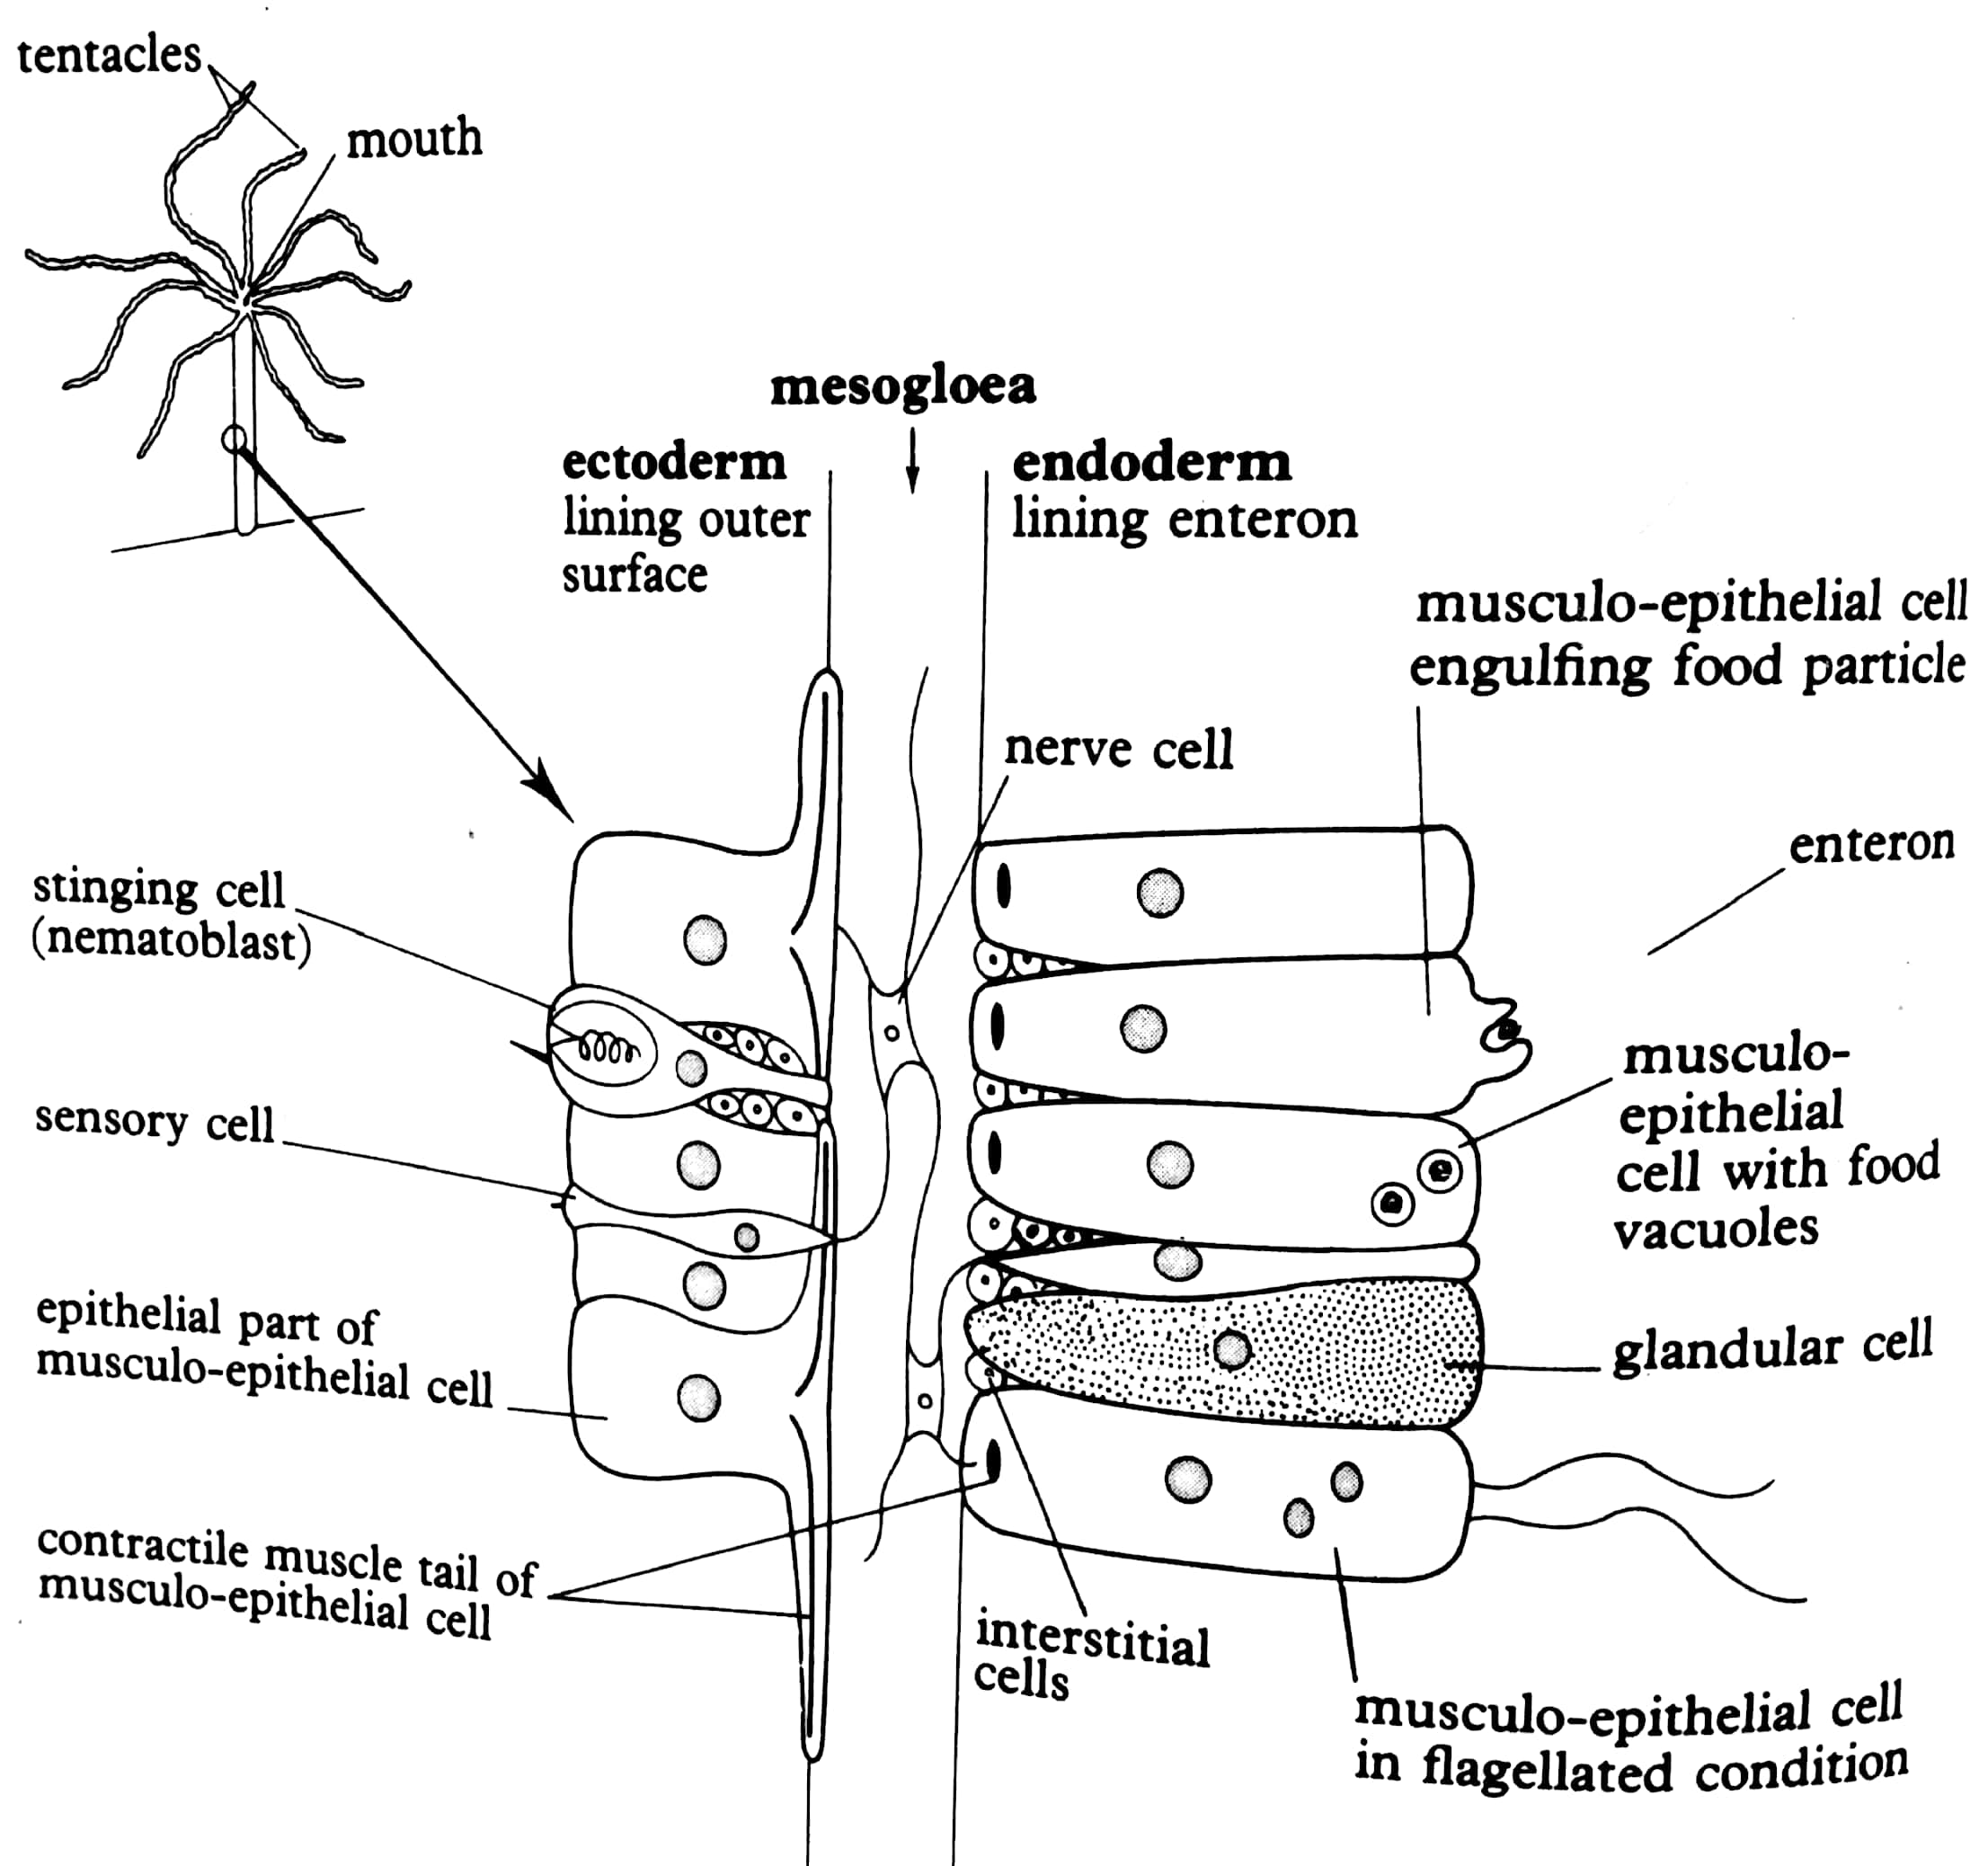

The wall of the hydra

It is composed of seven different types of cells arranged in two sheet like layers called ectoderm and endoderm. The ectoderm lines the external surface whereas the endoderm lines the body cavity/enteron.

Between the ectoderm and endoderm is an intersurface called the mesogloea in which there are nerve cells that are interconnected to form a nerve net. Each of the different cells performs a specific function as stated below.

* Musculo epithelial cells- These are cells lining the upper surface in the ectoderm and are mainly for protection.
* Nematoblasts- (stinging cells). It contains a thread which contains a toxic fluid. It is used in the piercing and poisoning of prey.
* Sensory cells- They are for detecting changes in the surrounding environment and pass impulses to the nerve cells.
* Nerve cells- They are interconnected to form a nerve net. They are connected to the contractile muscle tail of the musculo epithelial cell. Therefore, their role is to pass on the information ie conducting impulses to those muscle tails of the musculo epithelial cells.
* Muscle tails- They are contractile muscles at the base of each musculo epithelial cell. They are concerned with bringing about the movement or beating of the tentacles and flagella when they contract.
* Glandular cells- They secrete enzymes that carry out digestion in the enteron.
* Phagocytic musculo epithelial cells- For taking in small particles from the enteron so that digestion is completed intracellularly.
* Flagellated musculo epithelial cells- Are important for effective movement of materials eg food materials and stirring it up in the enteron.
* Interstitial cells- For generation or production of new cells.

Feeding mechanism in a hydra

Food of a hydra is usually water fleas. The water fleas are immobilized by the stinging cells and pulled to the mouth by the by the tentacles under the influence of the contraction of the muscle tails which are controlled by the nerve net in the mesogloea.

When the food reaches in the enteron, digestion starts by the enzymes secreted from the glandular cells. Digestion is completed inside the musculo epithelial cells which take up food particles from the enteron by phagocytosis.

1. Colonial organization

In colonial organization, cells are functionally isolated ie their activities are not co-ordinated. Each cell when isolated can exist on its own for example in a sponge. (structure FA page 45)

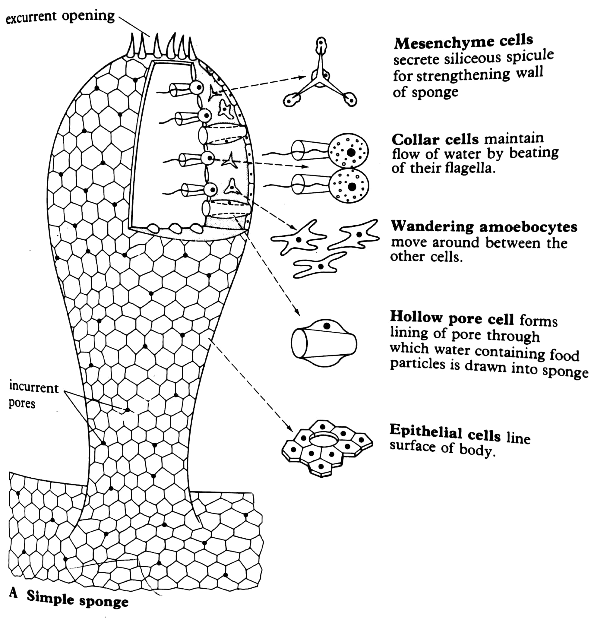

The various cells and their functions include:

1. Mesenchyme cells- These secrete siliceous spicule for strengthening the wall of the sponge.
2. Collar cells- These maintain flow of water by beating of their flagella.
3. Wandering amoebocytes- They move around between the other cells.
4. Hollow pore cell- It forms lining of pore through which water containing food particles is drawn into sponge.
5. Epithelial cells- They line the surface of the body
6. Organ level of organization

It is a group of organization where the physiological functions are mainly performed by organs and organ systems. An example is mammals. This form of organization occurs mainly in the higher multicellular animals.

Advantages of being multicellular

1. It allows increase in size.
2. It brings about specialization of specific cells for a particular function, thus improving efficiency of an organism as a whole. It permits exploitation of environment in which single celled organisms cannot live.
3. It allows development of better tissues for example muscles for quick movement, skeleton for support and quick movement.
4. There is also development of sophiscated physiological mechanisms eg maintenance of body temperature.